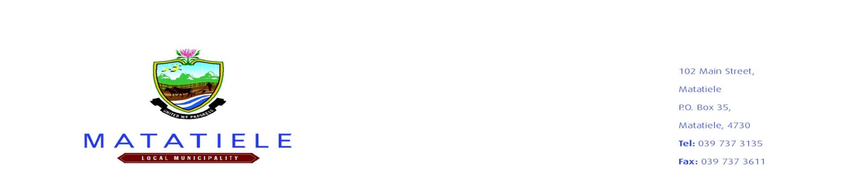
MATATIELE LOCAL MUNICIPALITY
APPLICATION FOR APPROVAL OF ADVERTISING AND SIGNAGE
As per the Matatiele Local Municipality tariff of charges for financial year 2025/2026
NAME OF APPLICANT: ________________________________________________________________
ADDRESS OF APPLICANT: ______________________________________________________________
CONTACT DETAILS OF APPLICANT (EMAIL ADDRESS/CONTACT NUMBER):
________________________________________________________________
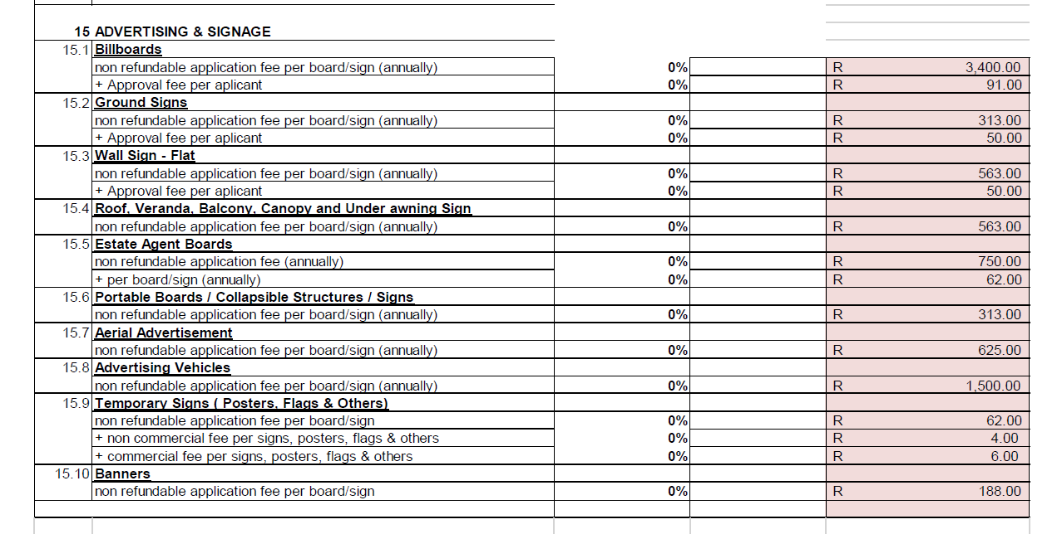
ADDRSS WHERE SIGN IS TO BE ERECTED: ________________________________________________

Please note that:
- A sum of R400,00 (rental)is payable every month for ground and streetpoles advertising on Municipal land/property
- A sum of R3000,00 (rental)is payable every month) rental for billboard advertising (on Municipal land/property)
- A sum of R500 is payable annually for ground, wall, and roof advertising on privately owned land/property
- A sum of R1000 is payable annually for billboard advertising on privately owned land/property
- No monthly rental for advertising in rural aeas
- Note that the Municipality will not be held responsible for loss or damage of the Billboard or Signs.
- Please take note that authorisation is valid for a period of one year (1 year) and renewable annually on sole discretion of the Municipality (Non-temporary signs).
You are required to submit:
- A separate sketch drawing (locality plan) indicating north and showing street names/ erf numbers where each sign is to be erected.
- A sketch drawing of the proposed signage design and content as well as dimensions and ground clearance where applicable.
- Removal of temporary signs at the end of the specified period at the cost of the applicant.

Signed by applicant: __________________________ Date: ___________________________

