T01

List of departmental delegation

Department: _EDP______________________________

No. | Name | Surname | Designation | Role at the Policy Conference Session
 | Siyanda | Ntshikilana | General Manager EDP | Presenter

T02

List of Local Economic Development Policies

Department: ___EDP- Local Economic Development ____________________________

NO | UNIT | Description | Status (Review/New/ Gazette )
1 | Local Economic Development | Business Licence Policy | Reviewed
2. |  | Matatiele LED Policy | Reviewed
3 |  | Grant In-Aid Policy | Reviewed
4. |  | Liquor Trading Policy | Reviewed
5. |  | Matatiele Relaxation Policy | Reviewed
6. |  | Agriculture Development Policy | New (Adopted)
7. |  | SMME Support Policy | New (Adopted)
8. |  | Disaster Response for SMMEs funding policy | New (Adopted)
9. |  | Policy for Emerging Micro Enterprise Development Support Contractor Development Policy(Incubator programme ) | New (Adopted)
10. |  | Tourism and Heritage Development Policy | New (Adopted)
 |  | By-laws
7. |  | Street Trading Bylaw  This bylaw is regulating informal businesses ‘that are operating in Matatiele town, Cedarville and Maluti Township. | Gazetted
 |  | Liquor Trading Bylaw  This bylaw is regulating liquor trading hours in the jurisdiction of Matatiele Local Municipality. | Gazetted
8

T03

Policy review or new policy proposals

DEPARTMENT: | EDP -Local Economic Development Unit

NO | POLICY | PAGE No. | POLICY SECTION & CLAUSE | PROPOSED INPUT/POLICY AMENDMENTS | MANDATE OR POINT OF REFERENCE FOR THE INPUT/AMENDMENT | COMMENT
1. | Grant-in aid- Policy |  |  |  |  | Review without comments
2. | Matatiele LED Policy |  |  |  |  | Review without comments
3. | Liquor Trading Policy |  |  |  |  | Review without comments
4. | Matatiele Relaxation Policy |  |  |  |  | Review without comments
5. | Business Licence policy |  |  |  |  | Review without comments

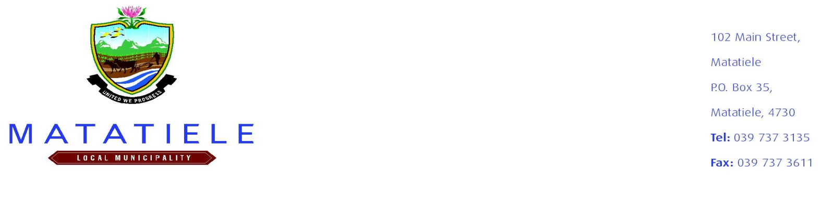

Local Economic Development Policies

No’s | Name of the policy | Overall objective of the Policy | Adopted
 | MLM SMME Policy | The policy specifically seeks to achieve the following objectives:  - To encourage the culture of entrepreneurship  - To improve access to business information  - To facilitate access to skills training  - To facilitate access to business mentorship  - To facilitate access of funding support to other institutions  - To facilitate business establishment  - To facilitate business plan development  - To facilitate market opportunities through business exposure  - To improve access to markets and business opportunities  - To improve access to appropriate infrastructure and services. | New
 | MLM  Agricultural Development Policy | The policy specifically seeks to achieve the following objectives:  - To inspire the culture of Agriculture in the Matatiele Local Municipality.  - To grow the economy of Matatiele Local Municipality in the Agricultural Sector.  - To increase and improve the level of primary production within the agricultural sector in Matatiele Local Municipality.  - To create sustainable job opportunities.  - To commercialise Matatiele Local Municipality farmers.  - To exploit Matatiele Local Municipality competitive advantage. | New
 | MLM Tourism and Heritage Development Policy | The policy specifically seeks to achieve the following objectives  - To improve community participation and the promotion of sustainable and responsible tourism.  - To clearly map out the process of SMME selection for participation in tourism related programmes in MLM.  - To identify mechanisms that will assist towards improving access to tourism support for tourism businesses  - To promote investment for tourism infrastructure and development.  - To improve the tourism coordination and planning.  - To support heritage initiatives that ensure a lasting legacy  - To encourage heritage ventures that celebrate the diaspora and those new to the local area | New
 | MLM Disaster Response for SMMES Funding Policy | The overall objective of the Vuka Alfred Nzo Funding Policy is to stimulate the number of businesses and the level of economic activity within the MLM, in order to rapidly eradicate poverty, reduce unemployment and create additional sources of income generation for the poor communities of the district.  It is therefore at the forefront of this funding to aim at improving the viability and competitiveness of initiatives to ensure that they graduate to the next level of development – thus enabling them to participate in the main-stream economy and essentially reducing dependency and poverty levels. | New
 | MLM Policy for Emerging Micro Enterprise Development Support (Incubator Program) | The policy specifically seeks to achieve the following objectives  - To promote increased participation and opportunities by and for emerging enterprises in the Municipality’s Procurement processes;  - To promote broad-based black economic empowerment in emerging enterprises;  - To identify and assess minor contract opportunities within the Municipality for the development and support of emerging enterprises;  - To identify opportunities where minor contracts may be awarded to emerging enterprises;  - To identify and align minor contracts with the development support programmes for emerging enterprises in the Municipality;  - To promote partnerships between the Municipality and the private sector in respect of the development and support of emerging enterprises;  - To promote skills transfer, training and accessibility to the processes of procurement through the implementation of the Emerging Enterprises Development and Support Programme of the Municipality; and  - To promote monitoring and evaluation of the identification and development of emerging enterprises. | New
 | Matatiele Local Municipality Relaxation policy |  | Old
 | Matatiele Local Municipality Led Policy |  | Old
 | Matatiele Local Municipality Grant-in -aid policy |  | Old
 | Matatiele Local Municipality Liquor Trading by-law |  | Old
 | Matatiele Local Municipality Street Trading bylaw |  | Old

