INTEGRATED WASTE MANAGEMENT PLAN (IWMP)

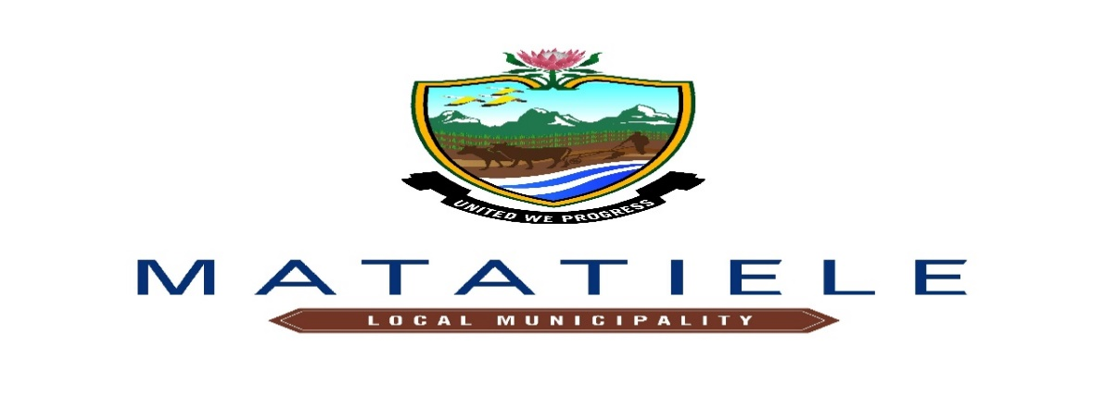

11 May 2023
Matatiele Local Municipality Integrated Waste Management P

CONTENTS
1. Defining the geographical area 5-6
2. Situation analysis 7
2.1. Demographics (Population and development profiles) 7
2.1.1. Growth&Demographic Profile .7-9
2.1.2. Dwelling Types................................................................................................................10-11
3. Determining current waste generation and estimating future waste generation rates and quantiies 12
3.1. Domestric Waste Generation .12
4. Waste quantities and types 13
4.1. Weighbridge .13
4.2 Volume density estimation system 13
4.3 Waste stream analysis 14-29
5. Waste recycling, treatment and disposal……………………………………………………………………….30
5.1. Status Quo of Waste Disposal Facilities ..30
5.2 Status Quo of Waste Treatment Facilities 31.
5.3 Status Quo of Waste Recyclers 32
6. National Domestic Waste Collection Standandards.............................................................. 33
7. Financing of Waste Management 34
7.1. Budget/Expenditure: Income and expenditure 34-35
7.2. Revenue sources 36
7.3. Organisational and institutional matters 37
8. Desired end state 43
8.1 Setting strategic goals, targets and indicators 43-47
9. Identify, evaluate and select alternatives 48
9.1. Strategic goals, targets, timeframe, budget 52
9.2 Communication and Stakeholder Participation 53
9.3. Consultation Process Summary 53
10. Implementation Instruments 54
10.1.1. Partnerships 54
10.2. Legislative instruments: Development and enforcement of by-laws 55
10.3. Funding mechanisms 56.
10.4. Implementation Plan (Summary of an IWMP Planning Process) 59-80
11. Reporting on Monitoring 83
11.1. Monitoring of the IWMP 84-85.
11.2. Performance 87
11.3. Communication and public participation plan 86
11.4. Financial plan 87
Annexure or References 88-90

BACKGROUND
The Matatiele LM Integrated Waste Management Plan (IWMP) has been developed in line with the requirements of the National Environmental Management Act (Act No. 59 of 2008), and the Department of Environmental Affairs (DEA) Guideline for the Development of Integrated Waste Management Plans.
As a requirement of section 11 (4)(a) of the National Environmental Management Waste Act (Act No. 59 of 2008), hereinafter referred to as the “Waste Act”, the National Waste Management Strategy 2020 and the Integrated Development Plan Process, all municipalities are obliged to compile an Integrated Waste Management Plan (IWMP). To fulfil this requirement, Community Services, Environment & Waste unit which is responsible for waste management (in the Matatiele Local Municipality: MLM) requested assistance from the Alfred Nzo District Municipality (ANDM), the Department of Economic Development, Environmental Affairs and Tourism (DEDEAT) as well as the Department of Forestry, Fisheries and the Environment (DFFE) and Matatiele Businesses to compile the IWMP for the Matatiele Local Municipality (MLM). The National Framework Guideline for the Development of Integrated Waste Management Planning (DEA, 2009a) and the National Waste Management Strategy 2020 which promotes waste minimisation, effective and sustainable services (November 2011) was referred to frequently in the compilation of the IWMP so to ensure that the Municipality provides efficient Waste management Service to the communities by collecting, Cleaning, giving an awareness and encouraging the green economy by providing skills in recycling to minimise waste going into the landfill site.
The National Environmental Management: Waste Act (NEMWA) (No. 59 of 2008) specifically requires IWMPs to set out priorities and objectives for waste management
- Establish targets for the collection, minimisation, re-use and recycling of waste
- Set out the approach to planning any new facilities for disposal and decommissioning existing waste disposal facilities
- Indicate the financial resources required for the IWMP
- Describe the implementation mechanisms for the IWMP

LEGISLATIVE FRAMEWORK

- Alfred Nzo District Municipality, 2007. Spatial Development Framework.
- Arcus Gibb Engineering and Science, 2010, Department of Economic Development and Environmental Affairs (DEDEAT): Eastern Cape Provincial Integrated Waste Management Plan, General Waste.
- Department of Environmental Affairs, Guideline for the designation of Waste Management Officers (WMOs) as provided for in Section 10 of the National Environmental Management: Waste Act (Act No. 59 of 2008).
- Department of Environmental Affairs, 2011, National Waste Management Strategy.
- Department of Environmental Affairs, 2006, South African State of the Environment Report.
- Environmental Conservation Act: Waste Tyre Regulations (Act No. 149 of 2001).
- Matatiele Local Municipality, 2015, Integrated Development Plan, 2015-2020.
- Municipal Solid Waste Tariff Strategy, 2012.
- Municipal Systems Act (Act No. 32 of 2000).
- National Domestic Waste Collection Standards, 2011.
- National Environmental Management: The Waste Act (Act No. 59 of 2008).
- National Environmental Management Act (NEMA) (Act No. 107 of 1998).
- National Health Act (Act No. 63 of 2003).
- National Pricing Strategy for Waste Management Charges, 2014.
- National Water Act (Act No. 36 of 1998)
- South African Constitution (Act No. 108 of 1996).
- Statistics South Africa: Census 2011 Data.

List Tables

Table 1: Demographics of Matatiele……………………………………………………………………………7-8
Table 2: table showing Population In Dwelling Types………………………………………………………….10
Table 3: Table showing Waste Quanties in Matatiele……………………………………………………………12
Table 4: Waste Quantities at the Matatiele Landfill Site………………………………………………………...13
Table 5: Table showing waste stream analysis…………………………………………………………………..14
Table 6: Medical waste in Matatiele LM…………………………………………………………………….19-20
Table 7: showing Observations made concerning commercial and industrial waste in Matatiele………….20-21
Table 8: Summary of status of existing waste collection equipment……………………………………………27
Table 9: UmAfrika Waste Recycler Operations…………………………………………………………………32
Table 10: Law and Flo Waste Recycler Operations……………………………………………………………..32
Table 11: showing the serviced and un-serviced households……………………………………………………33
Table 12 Budget/Expenditure: Income and expenditure…………………………………………………………34
Table 13 Revenue sources………………………………………………………………………………………..36
Table 14: showing Personnel responsible for refuse removal, cleansing and landfilling………………………..37
Table 15: Summary of the main waste management issues in Matatiele LM……………………………………38
Table 16: Table showing strategic goals, targets and indicators…………………………………………………44
Table 17 : strategic goals, targets, timeframe, budget……………………………………………………………47
Table 18: Consultation Summary………………………………………………………………………………..53
Table 19: Proposed Matatiele LM IWMP Implementation Plan……………………………………………..59-80
Table 20: Programme for monitoring the implementation the Matatiele LM IWMP……………………………81

List of Figures

Figure 1: A map showing the Geographic area of Alfred Nzo……………………………………………………5

Figure 2: A map showing Matatiele area………………………………………………………………………….6
Graph 1: Graph showing Population distribution………………………………………………………………09
Graph 2:A graph showing the dwelling types…………………………………………………………………...11
Graph 3: Graph showing Domestic waste generation graph…………………………………………………….12
Graph 4: Graph showing Matatiele Waste streams (in the CBD)……………………………………………….15
Graph 5: showing Matatiele Waste streams (in the Residential)………………………………………………..16
Graph 6: showing Matatiele Waste streams (in Businesses)……………………………………………………17
Graph 7: National Domestic Waste Collection Standards Graph of Matatiele Local Municipality……………..33
Graph 8 :Budget/Expenditure graph……………………………………………………………………………..35
Photo 1: Waste collection boundary for Matatiele CBD…………………………………………………………22
Photo 2: Waste collection boundary for Cedarville……………………………………………………………...23
Photo 3: Waste collection boundary for Maluti………………………………………………………………….24
Photo 4: Waste collection boundary for Harry Gwala and Mountain View……………………………………..25
Photo 5: Waste collection boundary for Buxton Park……………………………………………………………26
Photo 6: Matatiele LM Rear end loader truck……………………………………………………………………28
Photo 7: Matatiele LM Skip Loader truck……………………………………………………………………….29
Photo 8 : showing Matatiele Landfill site board………………………………………………………………..30
Photo 9: showing Compaction of waste…………………………………………………………………………30
Photo 10: showing Recycling…………………………………………………………………………………….31
Photo 11:Leachate pond………………………………………………………………………………………….31
Photo 12 : Pictures showing recycling activity…………………………………………………………………..32

Defining the geographical area

Figure 1: A map showing the Geographic area of Alfred Nzo

Matatiele Local Municipality is located in the Alfred Nzo District municipality in the Northern part of the Eastern Cape Province. Alfred Nzo District comprises of four local municipalities namely Matatiele, Umzimvubu, Winnie Madikizela and Ntabankulu Local Municipalities (MLM, 2014a). The municipality borders local municipalities of: Elundini Municipality to the South West, Greater Kokstad Municipality (KZN) to the East, and Umzimvubu Municipality to the South. The municipality also has cross border linkages with Lesotho to the North. (MLM IDP, 2018a).

Matatiele Municipality is the largest municipality in the district and covers an area of approximately 4 352 km². The municipality comprises of three urban centres, namely, Matatiele town, Cedarville and Maluti. Some of Matatiele LM’s notable physical characteristics include steep, mountainous terrain, many valleys, and a number of open spaces, poor road infrastructure, gravel roads and many footpaths, especially in the rural parts of the area. It is predominantly rural in nature with large tracts of agricultural land in the rural areas which are under-utilised. Most of it is communal land – meaning that it is privately owned. Rivers and wetlands are amongst the significant natural sources of water and the area is mostly covered or populated by grass, shrubs, wattle and indigenous trees of which one of Nature Reserve also has the Important plant species of Protea Trees.

According to the Census 2022 Community survey; Matatiele local municipality has a population size of 225 562 people, spread across 27 wards. This shows a slight increase in the population size over the last five years, since the 2011 census. A comparative demographical analysis demonstrates that Matatiele Local Municipality has the largest geographical size at 4352km² within Alfred Nzo District Municipality. The area accounts for 41% of the district’s population. In terms of Population density, Matatiele local Municipality has a rather lower density (46.8 p/square kilometre) within ANDM.
Socio-economic and demographic factors such as urbanization, unemployment and population growth has impacted negatively on waste trends within Matatiele Local Municipality. Increasing affluence not only leads to an increase in the quantities of waste generated but also affects the provision of waste services.

The economically active population (EAP) is defined as the number of people who are able, willing and who are actively looking for, work and who are between the ages of 15 and 64. 56.6% of the population of Matatiele falls within this category. Included in this category are those employed and unemployed people. According to Statistics South Africa, within Matatiele Local Municipality, 39 406 people are economically active (employed or unemployed but looking for work), and of these 38, 7% are unemployed. Of the 20 932 economically active youth (15 – 34 years) in the area, 47, 2% are unemployed.

Matatiele Local Municipality is characterized by high levels of unemployment and unequal distribution of income. According to SASSA (March, 2017) there are 58 786 beneficiaries receiving monthly grants in Matatiele. SASSA pay out an estimated R60 330 723.00 monthly to these beneficiaries. The Municipality has an Indigent support policy and an indigent register with more than 20 548 households registered.

The maps below depict the location of the Matatiele LM within the Alfred Nzo Region.
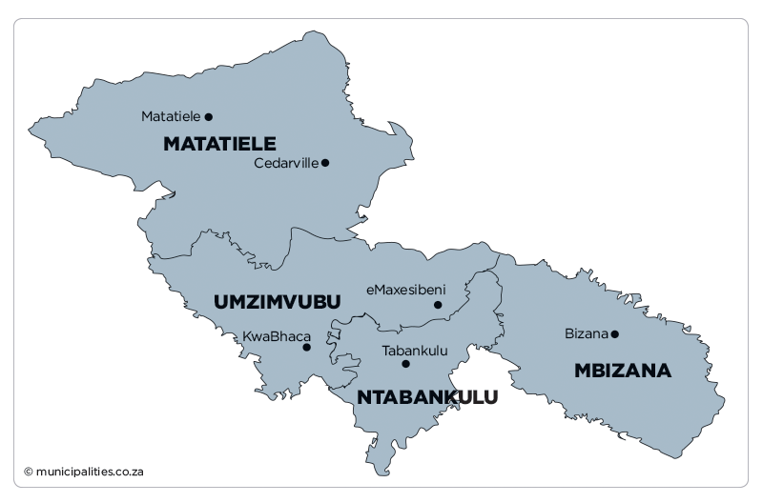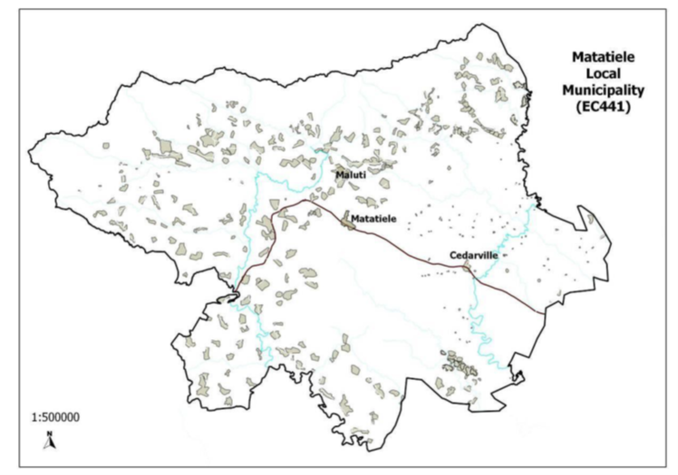
Figure 2: A map showing Matatiele area

Situation analysis

Demographics (Population and development profiles)
2.1.1 Growth & Demographic Profile
According to the Census 2022 Community survey; Matatiele local municipality has a population size of 225 562 people, spread across 27 wards. This shows a slight increase in the population size over the last five years, since the 2011 census. A comparative demographical analysis demonstrates that Matatiele Local Municipality has the largest geographical size at 4352km² within Alfred Nzo District Municipality. The area accounts for 41% of the district’s population. In terms of Population density, Matatiele local Municipality has a rather lower density (46.8 p/square kilometre) within ANDM.
Socio-economic and demographic factors such as urbanization, unemployment and population growth has impacted negatively on waste trends within Matatiele Local Municipality. Increasing affluence not only leads to an increase in the quantities of waste generated but also affects the provision of waste services.

Table 1: Demographics of Matatiele

Growth estimates
Municipality Population (as per Census 2011): | 203843
Estimated Population Growth (%) as per Census 2022: | 1.0
Estimated current population as of Census 2022(year is a parameter): | 225 562
Demographic profile
Age:
Youth | 149598
Middle age | 49697
Old age | 26265
Gender:
Male | 105977
Female | 119585
Education:
Primary | 88986
Secondary | 69706
Tertiary | 4994
Employment:
Employed | 24163
Unemployed | 115753

The majority of the population is African at 98.4%, while Coloured, Indian/Asian and White population groups, constitute 1%, 0.2% and 0.4% respectively. The majority of the population is mostly residing in rural villages around the towns of Matatiele, Maluti and Cedarville.

54% of the population of Matatiele Local Municipality is females. There are more females than males (46%). This is not a unique case of MLM as this trend is also evident within the district, province and the country as a whole.

Graph 1: Graph showing Population distribution
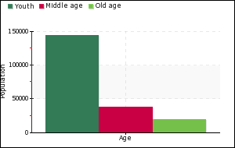 | 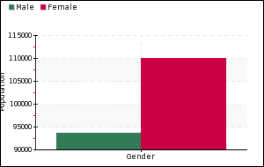
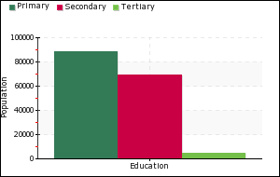 | 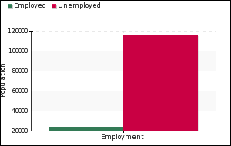

2.1.2 Dwelling Types
Table 2: table showing Population In Dwelling Types
House or brick/concrete block structure on a separate stand or yard or on a farm: | 16524
Traditional dwelling/hut/structure made of traditional materials: | 21410
Flat or apartment in a block of flats: | 2879
Cluster house in complex: | 75
Townhouse (semi-detached house in a complex): | 132
Semi-detached house: | 290
House/flat/room in backyard: | 4441
Informal dwelling (shack in backyard): | 444
Informal dwelling (shack not in backyard e.g. in a informal/squatter settlement or on a farm: | 253
Room/flatlet on a property or larger dwelling/servants quarters/granny flat: | 252
Caravan/tent: | 33
Other: | 2793

Graph 2:A graph showing the dwelling types

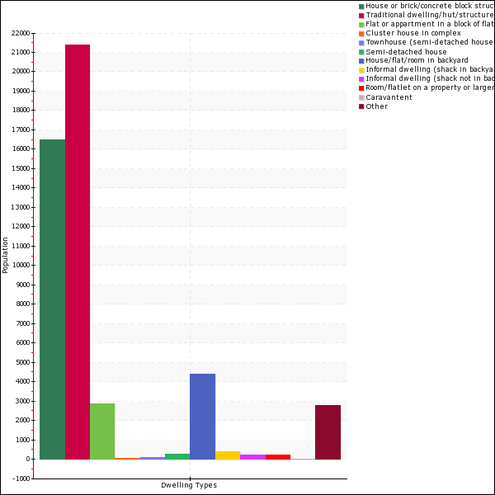

3. Determining current waste generation and estimating future waste generation rates and quantities

3.1 Domestic Waste generation
Table 3: Table showing Waste Quanties in Matatiele
Current waste generation and estimated future waste generation
Current domestic waste generation rates | 800.37 tons
Future domestic waste generation rates (in 10 years) | 1000.7 tons

Graph 3: Graph showing Domestic waste generation graph

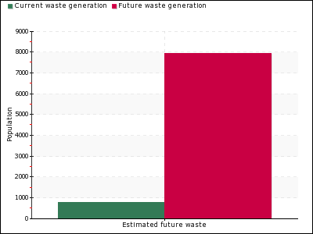

4. Waste quantities and types
Matatiele LM receives waste from three main urban areas Maluti, Cedarville and Matatiele. There are 5 contracted service providers who bring in waste into the landfill site from wards 1(Maluti), 19((Buxton Park, New J& West end) and CBD) and 20 (Harry Gwala, North end, Itsokolele and Dark City) as well as in-house collection from Cedarville using the municipal compactor and skip loader trucks. Matatiele LM landfill site also receives general waste from various businesses such as Cashbuild, Drakensberg Abattoir, building rubble from contractors and tyre dealers. The municipality also services government institutions such as clinics and schools.

4.1 Weighbridge

During the site visit and investigation (12 July 2022), there was no weighbridge at the landfill site and waste volumes were estimated/ quantified by the number of truck trips to the landfill waste site. Currently, there is a weigh-pad on site, and it is operational, though there is a challenge as there is no electricity at the landfill site and the weighbridge has to be charged offsite at least 3 times a week (on Mondays, Wednesdays and Fridays).

At the time of the site visit there was visible accumulation of waste tires was observed
. The landfill site is reaching capacity and requires new cells, considering that certain portions of the landfill site cannot be used as they are wet areas. Reporting on the South African Waste Information System (SAWIS) is inconsistent due to contractual matters with the service provider of Amacwele (name of the service provider).

4.2Volume density estimation system
Table 4: Waste Quantities at the Matatiele Landfill Site
Matatiele Landfill site
Waste type/streams | Waste generated per annum (tons) | Total percentages
Organic waste | 2958 | 46.7779 %
Cans | 118 | 1.86606 %
Paper | 1302 | 20.5899 %
Glass | 631 | 9.97865 %
Plastic | 1124 | 17.775 %
Construction and demolition waste | 181 | 2.86234 %
Tyres | 9.5 | 0.150233 %
Other | 0 | 0 %
Total | 6323.5 | 100 %

4.3 WASTE STREAM ANALYSIS
Table 5: table showing waste stream analysis
Waste Stream | SAMPLE IN KG
Waste Stream | CBD |  |  |  |  | RESIDENTIAL |  |  | CASHBUILD
Waste Stream | 1 | 2 | 3 | 4 | Sample Total (CBD) | 5 | 6 | Sample Total Location) | 8 | 9 | 10 | 11 | 12 |  | Sample Total
PET | 2.075 | 0 | 0 | 0 | 2.075 | 0.135 | 0 | 0.135 | 0.825 | 0 | 0 | 0 | 0 |  | 0.825
HDPE | 1.98 | 0 | 0 | 0 | 1.98 | 0.56 | 0 | 0.56 | 0 | 0 |  | 0 | 0 |  | 0
Paper | 1.54 | 1.315 | 1.285 | 2.605 | 6.745 | 0.92 | 0 | 0.92 | 1.55 | 2.56 | 0 | 0 | 0 |  | 4.11
Organic | 2.18 | 0 | 0 | 0 | 2.18 | 16.46 | 7.03 | 23.49 | 0 | 0 | 0 | 0 | 0 |  | 0
Polysterine | 0.65 | 0 | 0 | 0 | 0.65 | 0.02 | 0 | 0.02 | 0 | 0 | 0 | 0 | 0 |  | 0
Plastics | 2.125 | 0 | 0 | 0 | 2.125 | 1.775 | 1.905 | 3.68 | 10.03 | 0.845 | 1.83 | 2.125 | 0.645 |  | 15.475
Cardboard | 0.855 | 0.975 | 0 | 0 | 1.83 | 1.14 | 2.43 | 3.57 | 2.37 | 1.26 | 0 | 0 | 0 |  | 3.63
Glass | 5.95 | 0 | 0 | 0 | 5.95 | 3.285 | 3.285 | 6.57 | 2.82 | 0 | 0 | 0 | 0 |  | 2.82
Diapers | 3.76 | 0 | 0 |  | 3.76 | 0.085 | 0.085 | 0.17 | 0 | 0 |  | 0 | 0 |  | 0
Textile |  | 0 | 0 | 0 |  | 1 | 0 | 1 | 0 | 0 | 0 | 0 | 0 |  | 0
Metal |  | 0 | 0 | 0 |  | 0.08 | 0 | 0.08 | 0 | 0 | 0 | 0 | 0 |  | 0
Electronic | 0 | 0 | 0 | 0 | 0 | 0 | 0 | 0 | 0 | 0 | 0 | 0 | 0 |  | 0
Other/Mixed | 4.64 | 0 | 0 | 0 | 4.64 | 2.175 | 0 | 2.175 | 15 |  |  |  |  |  | 15
Total |  |  |  |  | 31.935 |  |  | 42.37 |  |  |  |  |  |  | 41.86

Graph 4: Graph showing Matatiele Waste streams (in the CBD)

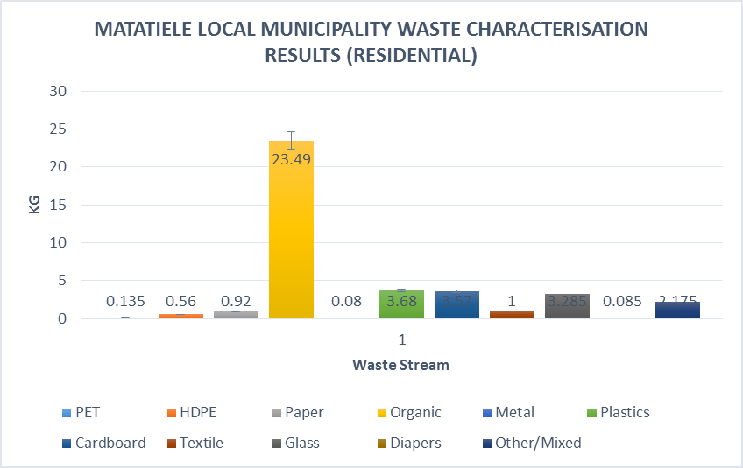
Graph 5: showing Matatiele Waste streams in the Residential

Graph 6: showing Matatiele Waste streams (in Businesses)

Waste characterisation that was done just snapshot a representative sample of Matatiele. Field observations of household waste streams suggest that domestic waste tends to have higher percentage of food refuse, garden, plastic, paper, and fabric. Observations and consultations with landfill operators also indicated that there is a lot of food refuse, and most of it is being fed to livestock (pigs) or domestic animals (dogs), sometimes even scavenged by the informal waste reclaimers at the landfill site illegally .this is controlled by issuing permits to the Landfill site which limits the number of scavenging within the landfill.

4.4 Future plans for waste generation
Food waste: the management will explore food composting which is currently done by local farmers to produce manure and the are companies that approached the Municipality about creating energy from waste (converting waste to energy)
We will also develop the buy back centre to reduce the amount of waste that goes to the landfill site

4.5 Medical waste
The following arrangements exist for medical waste in healthcare facilities located in Matatiele LM:

    - Public
The Provincial Department of Health manages all medical waste produced by the public medical facilities within Alfred Nzo District Municipality (ANDM). The district municipality has a service provider responsible for the collection and transportation of medical waste from public clinics (bi-weekly) and community health centers (once a week). This waste is transported to the Biomed Disposal Serrvices public hospital within the district, where it is collected by a bigger service provider, Compass Waste, to the treatment facility in Berlin, East London.

Public medical facilities that the DOH services, include:
- One district hospital (Tayler Bequest Matatiele Hospital)
- One TB Hospital
- Maluti Community Health Centre
- 17 clinics
- Two Mobile clinics

    - Private
The management and monitoring of medical waste generated by private facilities (i.e. funeral parlors, GPs and pharmacies) remains the responsibility of the district Municipal Health Services’ unit of the Community Development Services’ department. This unit is responsible for establishing and maintaining a database of all general practitioners, pharmacies, funeral parlors etc. to ensure that they are all legally registered and licensed, and to monitor if they are registered with an accredited service provider for medical waste collection. Please refer to Appendix D for a database of all private medical facilities within ANDM, and whether they are registered with a service provider or not.

Private medical facilities that Matatiele LM services, include:
- Matatiele Private Hospital
- 16 medical practitioners
- 3 Pharmacies
- 20 Funeral parlours
- Traditional healers

Table 6: medical waste in Matatiele LM
Sector | Activity | Observations
Medical | Hospitals | There is a large hospital complex in Matatiele which generates various waste streams, including:  - Human body parts (amputations, placenta, surgically removed tissues, etc.)  - Used syringes  - Expired drugs and medications  - Used dressings  - Etc.  The estimated medical waste from the hospital ranges from 300 kg’s to 400 kg’s per month
Medical | Clinics | Medical waste from the clinics weigh up 80 kg’s per month
Medical | Medical practitioners | Medical waste from the Practitioners weigh up 40 kg’s per month.
Medical | Pharmacies | Medical waste from the Pharmacies weigh up 40 kg’s per month as well because they recycle back most of their expired tablets and medication to their suppliers.

Commercial and industrial

Commercial waste observed in the various urban areas in Matatiele LM typically comprises cardboard, paper, plastic and glass.
Some of the commercial and industrial waste streams noted in Matatiele LM are summarised in the table below:

Table 7: showing Observations made concerning commercial and industrial waste in Matatiele LM
Sector | Activity | Observations
Commercial | General | Commercial waste observed in the various urban areas in Matatiele LM typically comprises cardboard, paper, plastic, glass, fabric, etc.
Commercial | Wholesalers and cash-and-carries | The various wholesalers and cash-and-carries seen in Matatiele LM, appear to generate a significant quantity of cardboard and plastic wrapping material.
Commercial | Abattoirs | A local abattoir in Matatiele generates various waste streams, including, blood water, offal, “paunch manure” from cattle stomachs, which is shred and composted by the local farmers  Waste produced by abattoirs is also categorised as hazardous waste.
Commercial | Garages/workshops | There are numerous workshops that generate:  - Used oil  - Old tyres  - Other old motor parts  The above waste items can also be categorised under the hazardous waste stream.
Commercial | Funeral parlours | There are numerous funeral parlours in the town of Matatiele and also in Maluti. The nature of wastes would include body parts, embalming fluids, etc. Most waste produced by funeral parlours is also hazardous.
Commercial | Building debris | Non-hazardous and hazardous (e.g. asbestos) building debris could also fall within the commercial waste category.
Industrial | Agricultural waste | There is very little knowledge of the waste streams generated by private and commercial farms, but is likely to include the following:  - Pesticide, herbicide and fertilizer residues and containers.  - Old equipment  - Oils and lubricants etc. from servicing equipment  - Etc.

  - Hazardous waste
There are no other activities in Matatiele LM that generate significant quantities of hazardous waste that are not already covered in the discussions above relating to medical, commercial and industrial waste streams.

  - Domestic waste collection maps
The following aerial images indicate the physical extent of current waste collection services in the various Matatiele LM urban centres. Based on these images, it would appear that the main urban centres of Matatiele and Cedarville have good service coverage, while many households in the Maluti and peri-urban areas in Matatiele do not receive services so since the majority of our villages do not waste collection service but we have piloted removal reuse of skip bin which we use as transfer stations focusing mainly on disposable nappies.

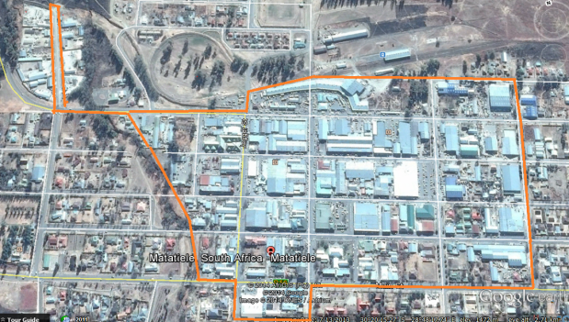 Legend
Photo 1: Waste collection boundary for Matatiele CBD boundary of Matatiele CBD

B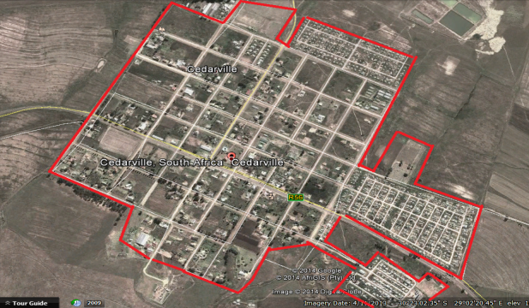 Legend
Photo 2: Waste collection boundary for Cedarville Cedarville Waste Collection Boundary
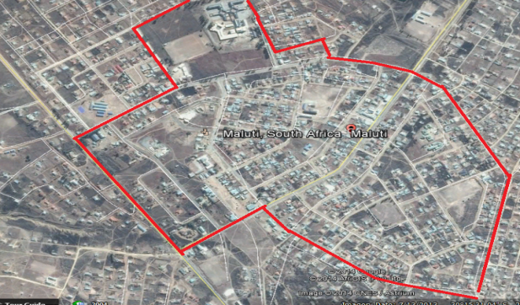 Legend
Photo 3: Waste collection boundary for Maluti Maluti Waste Collection Boundary
Mountain View 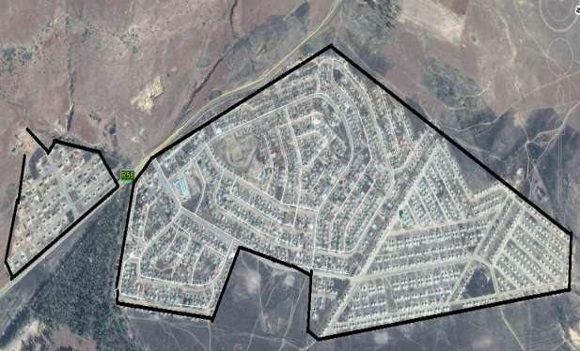 Harry Gwala
Photo 4: Waste collection boundary for Harry Gwala and Mountain View

Legend
Harry Gwala and Mountain View Waste Collection Boundaries

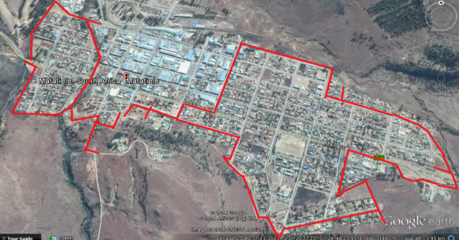
Photo 5: Waste collection boundary for Buxton Park

Legend
Braxton Park Waste Collection Boundary

  - Commercial, industrial, medical and hazardous waste
There is no data on quantities of commercial, industrial, medical and hazardous waste generation in Matatiele LM, although in combination these waste streams are likely to be significant.

Commercial waste in Matatiele LM takes various forms and includes:
- Packaging materials - Packaging materials, such as cardboard boxes and plastic are generated in large quantities particularly in urban areas of Matatiele particularly the wholesalers. In all areas, this waste is generally collected by the municipality and local private recyclers who are supported by the Municipality.

- Repair and body shops - Another major concern in Matatiele LM is the practice of burying old oily wastes at local mechanical repairs workshops, however there are some that restore the oil and sell it the used oil recyclers, the. This practice, though limited in scale, has long-term pollution potential for groundwater and local soil.

  - Rural areas
The municipality has introduced waste collection in rural areas by using transfer stations (skip bins) which are collected once a week or upon demand from the community. This is done to rural areas bordering the peri urban areas. Otherwise, there is no waste collection services that are provided for the rural areas within the municipality.

- Equipment
The Matatiele LM waste collection fleet and equipment is summarized in the Table below.

Table 8: Summary of status of existing waste collection equipment
Type | Model  (year) | Application | VEHICLE CONDITION**
Type | Model  (year) | Application | Poor | Fair | Good
Compactor truck | 2010 | Refuse Removal |  | x
Compactor Truck | 2019 | Refuse Removal |  |  | x
Skip bin truck | 2010 | Refuse Removal |  | x
Skip bin truck | 2018 | Refuse Removal |  |  | x
Refuse truck (Dome) | Old | Refuse Removal | x
Bakkie | Old | Inspection Vehicle |  | x

** Note that the indicated vehicles condition is a subjective assessment of the vehicles and no mechanical assessment of the vehicles had been conducted. The distinction that has been made between fair and good was purely based on the age of the vehicle.

a picture showing a Waste Compactor Truck
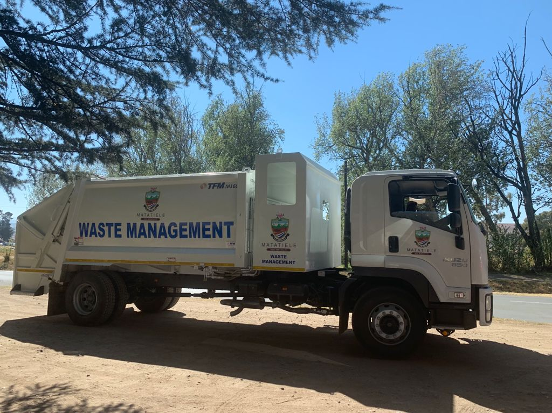
Photo 6: Matatiele LM Rear end loader truck

Pictures showing Waste Skip Bin Loader

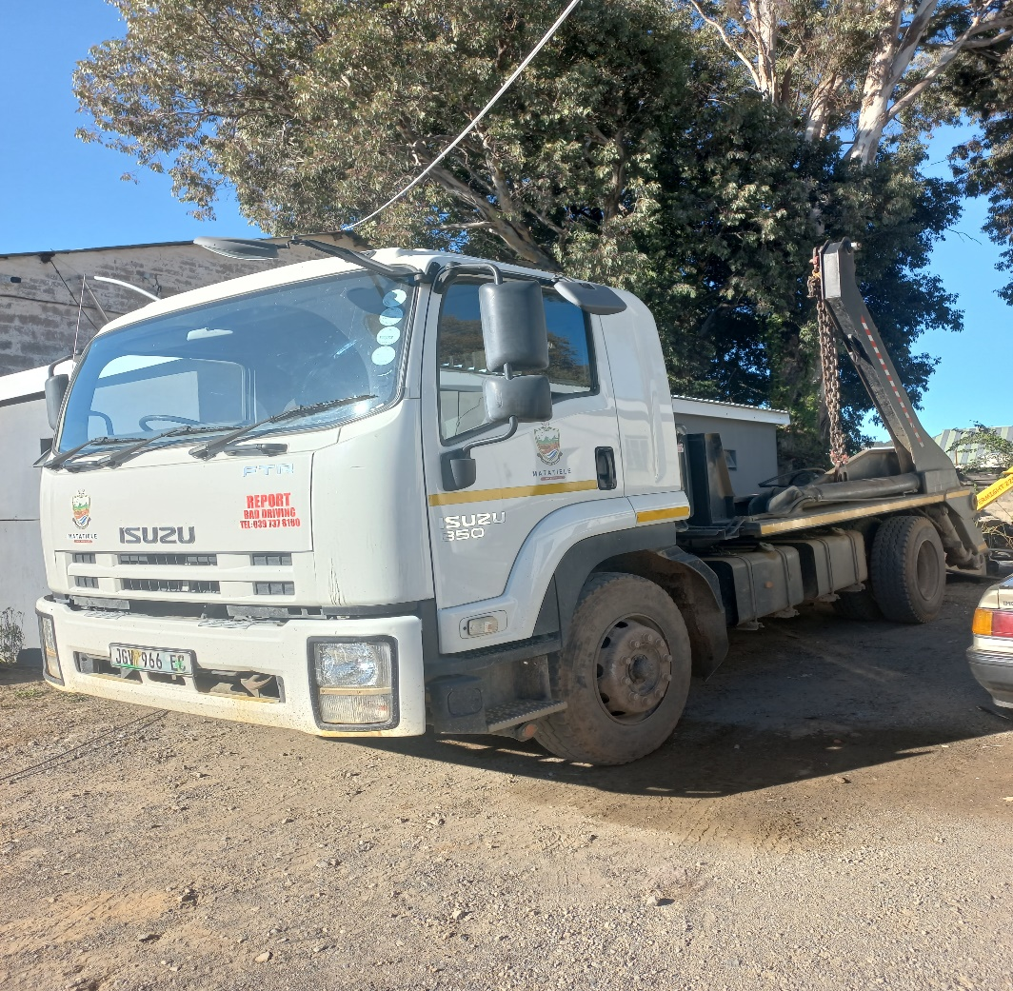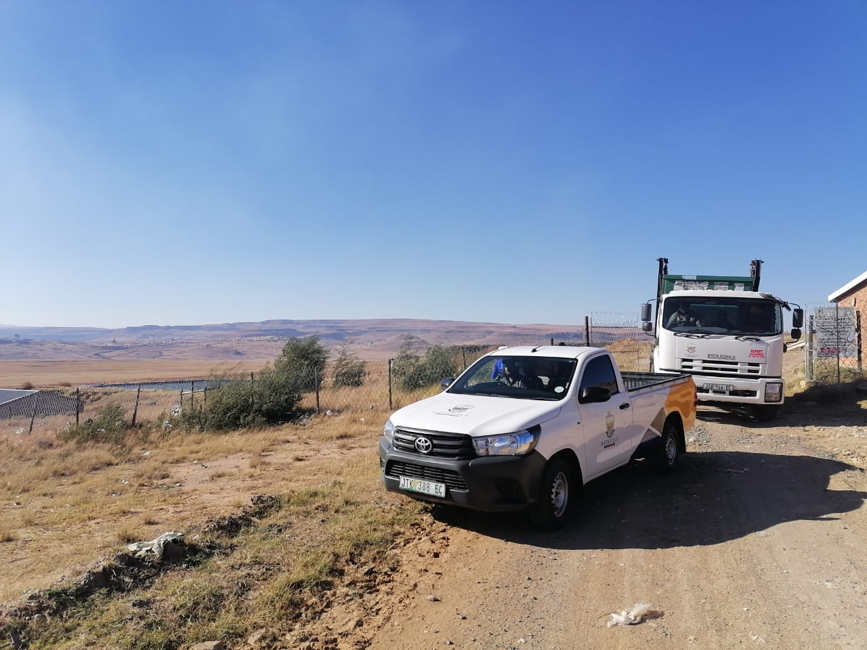
Photo 7: Matatiele LM Skip Loader truck

Waste recycling, treatment and disposal

Status Quo of Waste Disposal Facilities
The Matatiele LM operates one (1) GCB+ licensed landfill site in Ward 20 that has been operating since 2008. There was also a landfill site in Harry Gwala, but this has been since closed and rehabilitated.
There is a buy back center that is dysfunctional and it will be moved due to the bad condition where it is located, i.e the area is very wet. The municipality shall seek to comply with legislation when moving the buy back center.
1 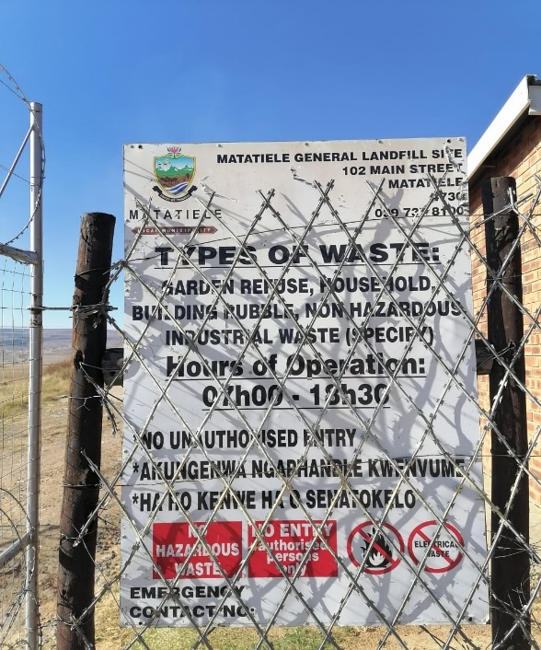2
Photo 8 : showing Matatiele Landfill site board
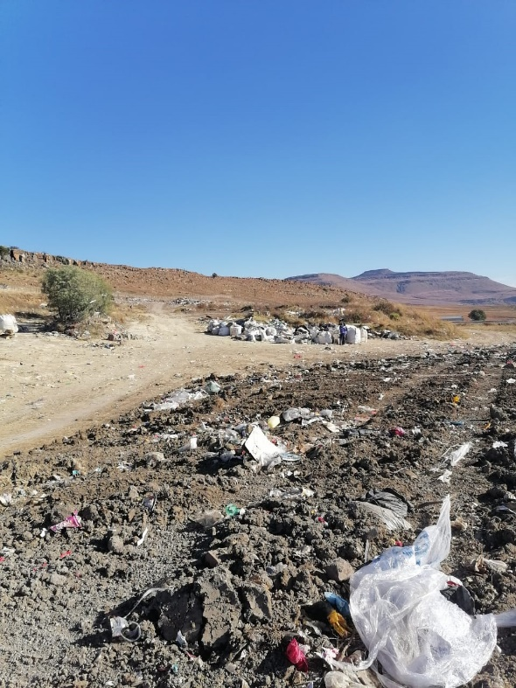
Photo 9: showing Compaction of waste
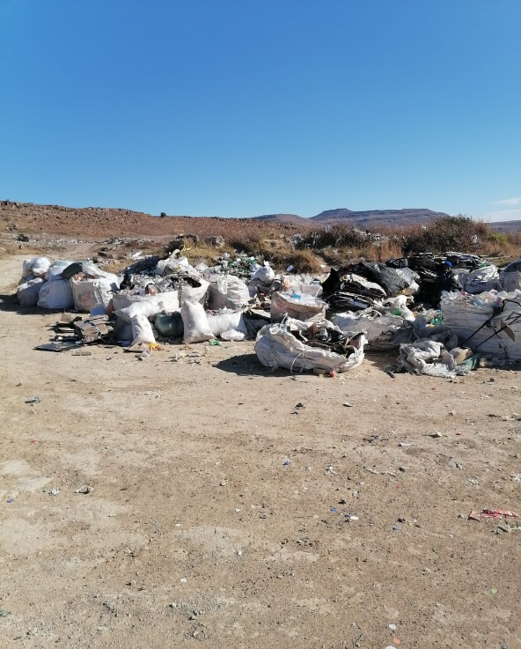
Photo 10: showing Recycling
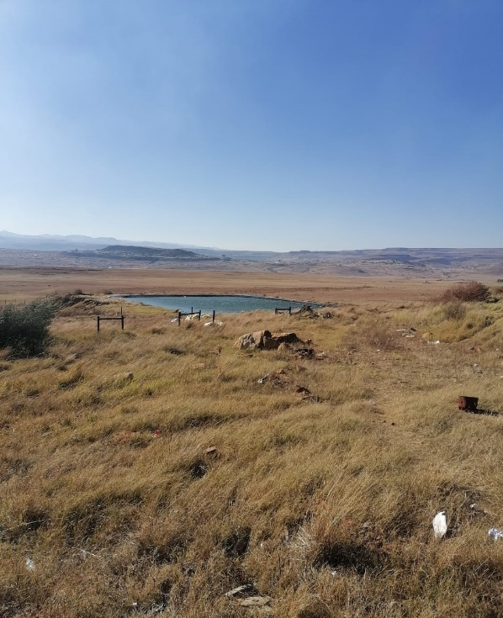4
Photo 11:Leachate pond

Status Quo of Waste Treatment Facilities
There are currently no waste treatment facilities under the operation of Matatiele LM. The municipality provides assistance to privately owned facilities.

Status Quo of Waste Recyclers
Table 9: UmAfrika Waste Recycler Operations
UmAfrica
Ownership | Private
Status | Pending registration Registered, due for review registration
Type/ stream of waste recycled per month (in Ton/kg) | cardboard
Volume of recycled waste per month(in Ton/kg) | 300 Ton
Total capacity | 500 Ton

Table 10: Law and Flo Waste Recycler Operations
Law & Flo
Ownership | Private
Status | pending registration with the provincial Department
Type/ stream of waste recycled per month (in Ton/kg) | cardboard
Volume of recycled waste per month(in Ton/kg) | 150 Ton
Total capacity | 500 Ton

Photo 12 : Pictures showing recycling activity
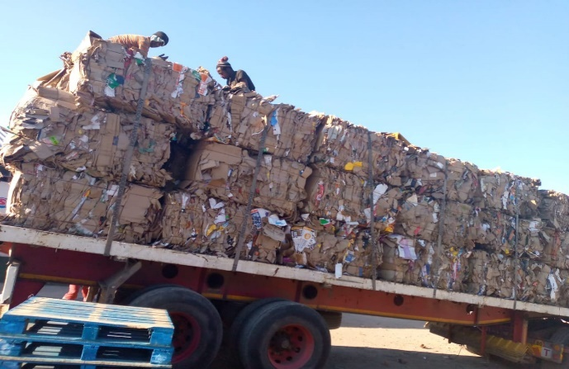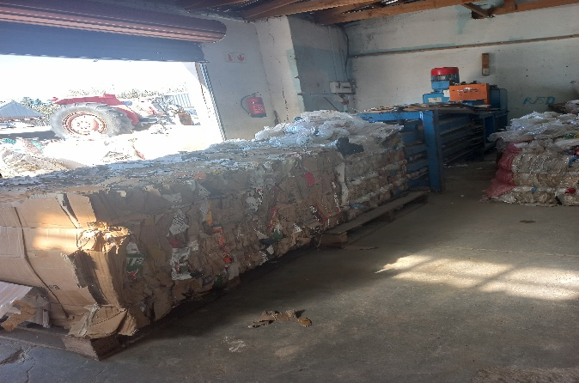

National Domestic Waste Collection Standards
There are illegal waste reclaimers at the landfill site targeting cardboard and plastic. However, they had been consulted regarding their illegal operation at landfill site. They have therefore been encouraged to seek a permit from the municipality. This has, however, not yielded any positive results. The municipality continues to engage the illegal reclaimers.

6.1. Waste collection
Table 11: showing the serviced and un-serviced households

Item | Total number
Households | 56872
Serviced households | 8828
Unserviced households | 48744
Indigent households | 1511
Unserviced indigent households
Service Level A: On-site appropriate and regularly supervised disposal | 0
Service Level B: Community transfer to central collection point: | 0
Service Level C: Organised transfer to central collection points and/or kerbside collection: | 8128
Service Level D: Mixture of Service Level B and Service Level C: | 700
Total Serviced households as per the National Domestic Waste Collection Standards: | 8128

Graph 7: National Domestic Waste Collection Standards Graph of Matatiele Local Municipality
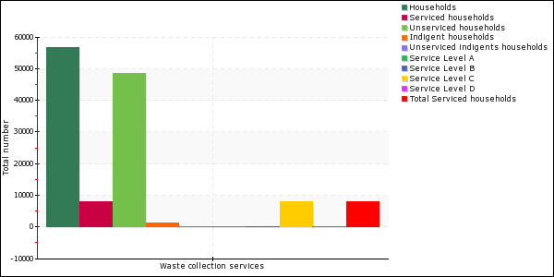

Financing of Waste Management

table 12:Budget/Expenditure: Income and expenditure
Item | Amount
Collection
Transportation | R 147 864 000
Capex-purchase (vehicles) | R 3816590
Maintenance | R 450 000
Fuel | R 2400 000
Receptacles | R 580260
General | R 200 000
 | R 0
Subtotal | R 155 310 850
Governance
Staff (remuneration) | R 4 993 812
Education and awareness | R 30000
IWMPS | R 0
By-laws | R 50 000
 | R 0
Subtotal | R 5 073 812
Disposal
Transfer station | R 0
Disposal sites | R 0
Acquisition of land, equipment | R 0
Regulatory compliance, EIA’s and licence | R 0
 | R 0
Subtotal | R 0
Total | R 160 384 662

7.1. Budgeting for waste services
The Municipal Systems Act (2000) requires that municipalities must ensure proper budgeting for services that they are required to provide.

Waste tariff system
Sources of funding for waste management in Matatiele LM include:
- Domestic and commercial waste services
- Provision for free basic services programme

Graph 8 :Budget/Expenditure graph

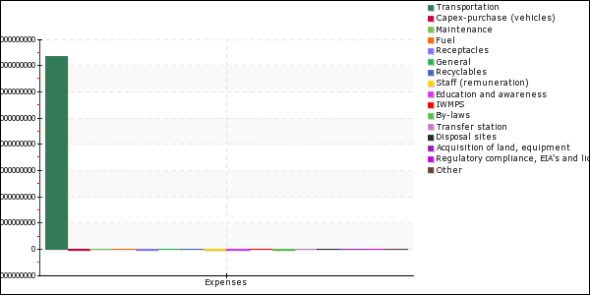
Table 13 :Revenue sources
Source | Amount
External Funding | R 0
MIG Funding | R 0
Equitable share funding | R 15000000
Revenue from waste disposal fees | R 15525768
Total | R 17025768

Organisational and institutional matters
The Environmental and Waste Management Services in the Matatiele Local Municipality are placed within the Community Services Department. The arrangement of the Environment and Waste Management Services unit is depicted below:

Figure 20: Organogram

Table 14: showing Personnel responsible for refuse removal, cleansing and landfilling.
Description | Number |  | Employment Status | Where Utilized
Description | Existing Posts  2020 | Vacant Posts  2020 | Employment Status | Where Utilized
Managers | 1 | 0 | Contract | Overall management
Senior Waste & Environmental Officer | 1 | 0 | Permanent | Supervising
Service Supervisor | 1 | 0 | Permanent | Monitoring
Drivers | 2 | 0 | Permanent | Collection and disposal
General assistants | 11 | 0 | Permanent | Cleaning, Collection and disposal in Cedarville and Matatiele

Personnel
Solid waste collection services (at Matatiele residential and CBD and Maluti) and cleansing of the towns is outsourced to independent service providers, but they are supervised by the Matatiele LM. The Cedarville area (CBD and residential area) is done in-house by the Municipality.

- Waste Management Issues in Matatiele

The main issues affecting waste management in Matatiele include the inadequate MIG funding, the lack of enforcement of the waste management by-laws, informal reclaimers operating at the landfill site, inadequate training and or capacity building initiatives, the lack of weighbridge and electricity at the landfill site resulting to off-site charging of the weigh-pad and estimation of waste quantities and the non-provision of waste management services in rural areas. The waste management issues are summarized in table 15 below, with proposed solutions.
Table 15: Summary of the main waste management issues in Matatiele LM
Themes | Issues and Observation
Themes | Previous (2014) | Current (2023)
Integrated Waste Management planning and implementation | - Establish guidelines on implementation of the plan and provide recommendations and allocate responsibilities.  - IWMP must set realistic ambitions and targets looking at available resources in the Matatiele LM.  - The IWMP should come up with short, medium and long term solutions to waste problem in the Matatiele LM.  - Planning time frames must be decided upon  - Time frames must be realistic and achievable  - Improve communications between municipal departments and other government agencies | - reporting of data to SAWIS
Institutional Framework | - Structures and responsibilities relating to waste management are not fully populated  - Lack of alignment with other initiatives e.g. Infrastructure, LED, and IDP etc.  - Waste management planning is fragmented and low on the agenda.  - Financial & capacity resources are limited  - Waste Management unit does not have input in the allocation of MIG funding | - Environmental management forums are not successfully supported  - Waste Management unit does not have input in the allocation of MIG funding
Regulatory framework | Legal compliance  - Matatiele LM needs to move toward legal compliance in terms of operation of landfill sites  By-laws  - There is a need to implement waste related by-laws | - Matatiele LM needs to move toward legal compliance in terms of operation of landfill sites  - By-laws are not effectively enforced  - Training of personnel (EMIs) in enforcement and compliance to by-laws  - By laws can assist in compliance and enforcement against:  - Used oils in garages and body works  - Uncontrolled disposal of waste from abattoirs  - Sludge disposal
Waste minimization, reuse and recycling | - Recycling and waste minimisation initiatives are not co-ordinated  - Limited formal waste prevention or minimisation practises are apparent, although there are some limited activities  - There is a great deal of recyclable material that goes into the landfill site (e.g. tyres, glass, cardboard, metal etc.) | - Informal “reclaimers” at landfill site can result in health and safety issues.  - There is a buy-back centre at landfill site, but it is badly positioned (downslope). It is currently not used.  - There are two (2) recognised private recycling agencies operating below capacity (UmAfrika & Law & Flo)  - There is limited recycling, considering the amount of recyclable material observed.  - LM looking into composting as a way of reducing garden waste.  - There is informal scrap metal collection
Capacity and Awareness | - Lack of community awareness on good waste management practices  - Widespread littering in urban and peri-urban areas  - Lack of awareness to businesses concerning good waste management practises | - Capacity building and training on waste minimization and recycling is limited.  - Waste Flood mopping group and Good Green Deeds Programmes assist in littering and cleanliness awareness’s
Municipal waste services | Waste management practices  - Inadequate municipal services and basic infrastructure  - Hazardous waste and medical waste entering landfill site  Urban waste collection services  - Waste collection is limited to the urban centres of Matatiele, Cedarville and Maluti  - There is limited performance monitoring of subcontractors  Peri-urban areas  - Poorly serviced urban and peri-urban areas  - On-site disposal is particularly noticeable in unserviced peri-urban, low-income housing and rural areas where waste is also often burned but residual non-burnable items are left on the ground. | - No weigh bridge for quantifying waste  - Refuse collection services contracted to 3 service providers, supervised by LM officials.  - Waste collection  - Matatiele CBD 7days/week  - RDP and Harry Gwala 3days/week  - Cedarville 2days/week (serviced by LM)  - Maluti 2days/week  - Equipment (excluding service providers’)  - 2 x skip loader  - 2 x compactor
Waste management in rural areas | - No waste services are provided in rural areas  - On site own disposal / burning is the predominant method for dealing with waste in rural areas.  - Lack of awareness concerning good waste management practises | - Pilot programme for waste removal on two rural wards has been implemented.  - No services provided in rural areas  - There needs to be a plan for rural waste collection.  - There appears to be a lack of awareness in rural areas concerning good waste management practices.
Medical waste | - Hospitals have adequate waste management practises, including medical waste  - Clinics generally have good practises for the disposal of medical waste, but some onsite burning of medical waste was observed at one rural clinic.  - Waste from various medical-related activities find their way into landfill site.  - Hospital waste also seems to get to landfill site.  - Waste disposal for funeral parlours is unknown | - Pharmaceutical waste (e.g. syringes) occasionally found at landfill  - Landfill site foreman to be trained on acceptance waste  - Health centres are serviced for general waste, Hazardous medical waste from health centres is collected by Compass Waste
Commercial waste | - Poor waste management at repair and body shops  - Used oils, tyres and other debris from service stations and body shops are generally disposed of at landfill site  - Building rubble lands in landfill site and sometimes it’s dumped illegally.  Motor vehicle repair and body shops  - Abandoned vehicles throughout Matatiele LM (particularly Maluti area).  - Oil spills from garages and motor repair shops were observed and oils and other debris from the numerous body shops and service stations, used paint containers and thinners are generally disposed of on-site (buried).  - Scrap metal from informal body shops is scattered around the yards | Same as previous and in addition:  - No information on generation of commercial waste  - Poor waste management at repair and body shops, hardwares
Landfill site | - Only one permitted landfill site  - poor operation and management of landfill  - Inadequate equipment for daily covering of waste  - Presence of waste pickers on site  - Leachate not being controlled and entering watercourses.  - Inadequate landfill space | - Scavenging/informal reclamation at landfill site  - Landfill site reaching capacity & requires new cells  - Not enough cover material  - Inadequate leachate management  - There is a weigh-pad for quantifying volumes of waste.  - LM outsourcing landfill maintenance and management.  - Off-site/backyard burning of waste  - Illegal dump sites in residential areas
Financial management | - Budgetary constraints  - Problems in accessing MIG allocation for waste services  - Services revenue collections are very low | - Budgetary constraints  - Problems in accessing MIG allocation for waste services  - Problems in accessing finance from DM.  - Services revenue collections are very low  - The specialised waste management vehicles program shall alleviate the lack of funding
Development challenges | - Poverty alleviation through environmental youth programmes/expanded public works programme  - High unemployment and poverty levels  - There is a high rate of urbanization.  - Spatial development framework under review | - Poverty alleviation through environmental youth programmes/expanded public works programme  - High unemployment and poverty levels  - There is a high rate of urbanization.  - Spatial development framework under review

10. Desired end state

Setting strategic goals, targets and indicators

Goal 1: Promote recycling and recovery of waste
Objectives | Targets | Activities | Timeframe
Promote waste minimisation, re-use, recycling & recovery | 80% of recyclables diverted from the landfill | Form private-Public partnerships | 2023/24 FY
The municipality to facilitate the establishment of Material  Recovery Facilities (MRFs) | Diversion of waste to the landfill site | Establish at least 2 buy back centers by 2024 | 2023/24 FY
Investigate waste-to-energy  options | Waste -to-Energy Plant | Investigate feasibility and implement measures to build Waste-to-energy facility at Matatiele Landfill site. | 2023/24 FY
Recycle all garden waste | Established composting facilities | Encourage companies to establish composting facilities and make available waste for compost. Encourage people to refer their garden waste to composting facilities  Practice zero garden refuse waste to Landfill site by 2023. | 2023/24 FY

Table 16: table showing strategic goals, targets and indicators
Goal 2: Ensure the effective and efficient delivery of waste services

Objectives | Targets | Activities | Timeframe
A comprehensive system for provision of waste to the urban node | 100% servicing of the 3 urban nodes | Conduct study on the no. of households serviced with skips within the urban node | 2023/24 FY
A system for provision of waste services to currently un-serviced areas and rural areas | 50% of servicing rural areas | Conduct studies on the no. of households per village in targeted wards (peri-urban) | 2023/24 FY

Goal 3: Ensure that legislative tools are developed to deliver on the Waste Act and other applicable legislation
Objectives | Targets | Activities | Timeframe
Annual review of waste bylaws | Ensure understanding of by-laws by all concerned | Develop guidelines for waste diversion from landfill disposal | 2023/24 FY
 | Ensure understanding of SOP by all concerned | Develop standard operating procedures (SOP) for the waste removal provision | 2023/24 FY
 | Ensure understanding of SOP by all concerned | Develop standard operating procedures (SOP) for waste management facilities | 2023/24 FY
 |  | Develop guidelines for registration of waste transporters within Matatiele LM boundaries | 2023/24 FY
 | To ensure all relevant staff is trained so as to be able to undertake all waste management services. | Training of Environmental Management Inspectors for Matatiele LM to monitor compliance & enforcement of by-laws and other environmental related transgressions | 2023/24 FY
Report effectively on the South  African Waste Information System  (SAWIS) | Submission of monthly reports. | Collect, sort, analyses, interpret and report waste volumes to SAWIS. Keep proper records of waste quantities and types received at the landfill site and other waste management facilities.  Submission of monthly reports | Ongoing

Goal 4: Sound budgeting and financing of waste management services
Objectives | Targets | Activities | Timeframe
Review tariffs for waste services provided | Cost reflective tariffs | Adopt DEA tariff model | Annually
Enhanced revenue collection | Ensure adequate and sustainable financing of waste services including cost recovery for waste services from user groups that are able to pay | Budget and financing model for waste management | 2023/24 FY

Goal 5: Ensure the safe and proper disposal of waste
Objectives | Targets | Activities | Timeframe
Existing waste management (disposal) facility are managed and monitored. | % compliance of the existing waste management facilities | Upgrade and ensure compliant management of existing waste management facilities. | 2023/24 FY
Conduct a feasibility study to determine establishment of composting facilities | Feasibility report for establishment of composting | If feasible, develop a composting strategy to divert green waste from waste disposal site. | 2023/24 FY

Goal 6: Education and awareness
Objectives | Targets | Activities | Timeframe
Conduct household awareness and education campaigns on proper waste management practices other environmental management issues. | Serviced households to be informed of waste management | Door-to-door education and awareness | On-going
 | Raise awareness to the general public | Community outreach | Ongoing
Establishment of local waste recycling forums | To discuss waste recycling challenges and possible solutions, coordinate waste minimisation, encourage growth on recycling, discuss possible initiatives for, or by, entrepreneurs, and dissemination of relevant new information with stakeholders | Establishment of local recycling forum committee  Hosting quarterly forums meeting and workshops. | 2023/24 FY
Development of educational and awareness plan in line with the Good Green Deeds initiative | Educational and awareness plan | Development of training materials to roll out education and awareness campaigns in line with GGD initiative | On-going
Emphasis on recycling in schools | Encourage and educate schoolers on the impotence of recycling | Establishment of a recycling competition at school level | 2023/2024
Establishment of local waste recycling forums | To discuss waste recycling challenges and possible solutions, coordinate waste minimisation, encourage growth on recycling, discuss possible initiatives for, or by, entrepreneurs, and dissemination of relevant new information with stakeholders | Establishment of local recycling forum committee  Hosting quarterly forums meeting and workshops. | 2023/24 FY
Awareness on the importance of whistle blowing |  |  | 2023/24 FY

Goal 7: Compliance and enforcement
Objectives | Targets | Activities | Timeframe
Reduce the number of dumping and littering sites | Reduction in illegal dumping and littering. | Put signs at the open spaces with fine and toll free number for illegal dumping | 2023/24 FY
 | Increase in numbers of prosecution for littering and dumping | Review the by-laws and enforce the By-laws | 2023/24 FY
 |  | Implement fining procedures. | 2023/24 FY

11.Identify, evaluate and select alternatives

Strategic goals, targets, timeframe, budget
Table 17: STRATEGIC GOALS, TARGETS, TIMEFRAME, BUDGET
Goal 1: Promote recycling and recovery of waste
Objectives | Targets | Alternatives | Budget
Reduce the quantity of recyclable material going to landfill by encouraging community to venture into recycling activities. | 0% of recyclable waste material at the landfill site | At least 10% of recyclable material should go to the landfill site. | R 100 000
The municipality to facilitate the establishment of Material  Recovery Facilities (MRFs) where appropriate | Material Recovery Facilities | Recovering waste materials from the existing refuse drop-off points and regional refuse transfer stations. | R 600 000
Investigate waste-to-energy  options | Waste-to-Energy Plant | N/A | R 2600000
Recycle all garden waste (Composting) | Municipal composting plan | Encouraging landfill users to refer their waste to an existing private composting facility. | R 650 000
Investigate waste-to-energy options | 10% per quarter | Explore different technologies | R200 000

Goal 2: Ensure the effective and efficient delivery of waste services
Objectives | Targets | Alternatives | Budget
Increase waste collection from  8128 to 12 000 households | 12 000 Households | Using an appointed private company to do waste collection from rural areas  Introducing transfer stations in rural areas | R6500000
Provide community with waste bins and colour coded refuse bags | Appropriate waste receptacles for residential areas and businesses by 2023/24 | Every household receiving waste removal services to be given appropriate waste receptacles | R2800000

Goal 3: Ensure that legislative tools are developed to deliver on the Waste Act and other applicable legislation
Objectives | Targets | Alternatives | Budget
Report effectively into South  African Waste information System  (SAWIS) | Ongoing | Electronic submission of data to SAWIS system administrator. | N/A
Review waste management bylaws | Ensure understanding of by-laws by all concerned | Using municipal communication platforms to ensure understanding of bylaws by the communities and businesses, review and make the existing waste management by-laws known by all concerned. | R 150 000
Review waste management Bylaws | Ensure understanding of by-laws by all concerned | Using municipal communication platforms to ensure understanding of bylaws by the communities and businesses, review and make the existing waste management by-laws known by all concerned | R 60 000

Goal 4: Sound budgeting and financing of waste management services
Objectives | Targets | Alternatives | Budget
Develop and implement (with DFFE) tariff model, one applicable to the municipality. | Cost reflective and volumetric tariffs. | No alternative | Internal
Enhanced revenue collection | Ensure adequate and sustainable financing of waste services including cost recovery for waste services from user groups that are able to pay |  | Internal
Maximize other sources of funding such as DBSA, COGTA, EPIP, EPWP grant, MIG DTI, Green Energy Efficiency Fund etc. | Increase alternative funding year on year | Using of a maximized municipal income fund to fund Waste Management Programme. | Internal

Goal 5: Ensure the safe and proper disposal of waste
Objectives | Targets | Alternatives | Budget
Stabilize quantity and investigate the reduction of pollution potential of waste disposed to landfill and reduce this volume | Waste -to-energy plant by 2023.  1 Composting Facility by end of  2023  1 MRF by 2023 | Encouraging landfill users to divert their waste to existing composting facilities and MRF’s. | Internal
Investigate the conversion of waste to energy projects | Waste-to-Energy Plant | Establishment of landfill Energy, gas and diesel | R 1500000
waste to energy and clean development mechanisms. | By 2023 | extraction for flaring instead of electrification can be used as an alternative.

Goal 6: Education and awareness
Objectives | Targets | Alternatives | Budget
Conduct household awareness and education campaign on waste management | Every household to be advised on waste management matters | Other stakeholders. | R30 000
Establishment of local waste recycling forums | To discuss waste recycling matters and dissemination of relevant information |  | R0

Goal 7: Compliance and enforcement
Objectives | Targets | Alternatives | Budget
Reduce the level of dumping and littering | Reduction in illegal dumping and littering.  Increase in numbers of prosecution for littering and dumping | Cleaning of illegal dump as and when it occurs. | Operational budget
Training of EMIs | Training Internal staff by 2023 | Ensuring enforcement of Bylaws | DFFE & LM

12.Communication and Stakeholder Participation

Consultation Process Summary

The in-house development of the Matatiele Local Municipality Integrated Waste Management Plan using the web portal was conducted in consultation with the following stakeholders on 27-29 August 2022 as attached on Appendix 1
- Alfred Nzo District Municipality (ANDM): Environmental Management
Regulatory Bodies
- Department of Forestry, Fisheries and the Environment, (DFFE)
- Department of Economic Development, Environmental Affairs and Tourism (DEDEAT)
The following stakeholders consulted before the finalisation of the Integrated Waste Management Plan:
- Matatiele LM Council
- Matatiele LM Technical Services
- Matatiele LM Development and Planning
- Community
Regulatory bodies:
- Department of Water and Sanitation, DFFE, DEDEAT, ANDM and Human Settlement
Table 18: Consultation Summary

Stakeholder | Issues raised/ Concerns | Municipality’s response | General comments
DFFE
DEDEAT
ANDM

13. Implementation Instruments

13.1 Partnerships

The municipality has agreements with the Department of Environment, Forestry & Fisheries where the department has been assisting the municipality through youth employment programs e.g. Good Green Deeds, Waste flood mopping group for carrying out waste clean up, awareness and education campaigns and general cleaning and greening of Matatiele.

The Matatiele Local Municipality intends signing a Memorandum of Understanding MOU with private institutions for the following activities:
1. Production of Biodiesel
• This will save airspace at the landfill site
• The biodiesel will be utilized for the municipal vehicles
2. Production of building blocks from diapers
• Diapers pose a challenge to the river system all around Matatiele LM
The building blocks from the recycled diapers will be used for building of low cost housing
- Management of waste management facilities
- The municipal waste management facilities will be managed by the private service providers

13.2 Legislative instruments: Development and enforcement of by-laws
The council of Matatiele local municipality gazetted the following Waste Management by-laws in terms of section 156 of the Constitution, 1996 (Act 108 of 1996) read in conjunction with section 11 and 98 of the Local Government Municipality Systems Act, 2000 (Act No 32 of 2000):

13.2.1 THE IWMP

The IWMP is the designated and legislated waste management planning tool. This plan has to identify and accommodate interested and affected parties with regards to waste management issues. Some of these parties are, but are not limited to: Ward Councilors and Committees, Business, Recyclers, Environmental institutions, and Municipal officials. The plan looks at waste management with an integrated point of view.

The designated WMO for the municipality is the Process Manager for Community
Development, who oversees all things that are waste management related. They ensure that monitoring is being done, in the present of appointments in terms of the organogram.
Waste Management in the Matatiele Local Municipality aided by the Environment and Waste Manager, Senior Waste Officer, Waste supervisor and general workers.
Business compliance is monitored by a Law Enforcement in the Public Safety Unit which is within Matatiele Local Municipality.

13.2.2 GENERAL DUTY IN RESPECT OF WASTE

This section in the Act involves the duty or obligation of anyone who generates waste to take steps within his or her power to avoid the generation of waste, reduce, recycle, and only treat and dispose of waste as a last resort. The municipality is playing its part by implementing this IWMP. This means that the implementation of the waste hierarchy becomes paramount.

13.2.3 EXTENDED PRODUCER RESPONSIBILITY (EPR)

The minister can identify products where the extended producer responsibility can apply. This means that customers can hold the manufacturer or source of the product responsible for its recycling or disposal, e.g. tyres, cans and electronic equipment, amongst other products. The municipality needs to be aware of such avenues and create communication channels to help solve problems within the municipality. This would be one of the duties of the WMO.

13.2.4 WASTE MANAGEMENT BY-LAWS

The major weakness of the by-laws is the lack of resources to enforce them. Traffic officers under Public Safety and EMIs within the Environment and Waste unit will play major roles in the communication and application of the by-laws. Prosecution of the perpetrators and the eradication of waste management offences.

13.2.5 COMPLIANCE AND ENFORCEMENT
Powers have been given to the environment management inspector (green scorpions) as well as the WMO to act if they have reason to believe that any provisions of the NEMWA were contravened or violated. The NEMWA provides for a maximum penalty of R10 000 000 or 10 years’ imprisonment or both.

13.3. FUNDING MECHANISMS

Funding for the waste management department can take the form of numerous options, all of which will serve to facilitate the effective and efficient operation of the department.
A critical precondition for the successful implementation of the Matatiele LM IWMP is the access to sufficient funds to carry out the plan.
With respect to the strategies already identified in Sections above, funding will possibly be required for the following recommended priority projects:
- Funding for various proposed programmes:
  - Waste management training and awareness programme for officials and councillors
  - Waste management awareness programme for the public
  - Waste management awareness initiatives for rural villages and ward councillors
  - Schools waste awareness programmes
  - Capacitating of officials for the implementation of by-laws
  - Formulate and implement an Operations Management Plan for expanding waste services by investigating alternative service delivery mechanisms, such as:
    - Communal bins or skips for non-serviced areas and illegal dumping hotspots
    - Defining clear waste collection points
  - Establishment of a Waste Information System
  - Audit programme for operating sites
  - Performance and legal compliance audit programme for service providers
- Operational funding for:
  - Establishing a waste minimisation/recycling office within Matatiele LM
  - Expanded services and alternative services
  - Better management of existing permitted landfill site
- Capital funding for
  - New landfill sites or expansion of existing landfill
  - New vehicles and other equipment (e.g. Waste Information System) required for solid waste management
  - Rehabilitation and closure plan for old site at Cedarville
- Funding for the development of various business plans:
  - Cleaner town and anti-litter awareness campaign and the cleanest town competition
  - Waste recycling feasibility study and initiate buy-back waste centre programme.
  - Paper waste
  - Communal collection points

FUNDING MECHANISMS
Funding mechanisms for Waste Prevention, Minimisation and Recycling
The primary source of initial funding for the waste prevention, minimisation and recycling activities is be sourced from:
- Municipal budget
- Donor funding
- Recycling agencies
- Public/private partnerships

Privately funded programmes should be promoted where possible.
Funding mechanisms for Waste Collection and Transportation
Possible sources for waste collection and transportation include:
- Payment for services (tariff revisions)
- Municipal budget allocations (equitable share)
- Donor funding for specific projects
- Public-private partnerships.

Funding mechanisms for Waste Treatment and Disposal
The cost associated with general waste disposal should mainly be funded by service fees (tariffs) or as part of other waste charges for the municipality.
As already described above the following two strategy documents must be consulted by the LM when reviewing and revising its tariff structure.
- Municipal Solid Waste Tariff Strategy (2012)
- National Pricing Strategy for Waste Management Charges (2014)

In particular, it is suggested that the LM investigate implementing waste tariffs that are volumetric based or “pay-as-you-go” versus a flat rate where there is no incentive to reduce waste and proper matching of costs.

13.3.1 BUDGET ALLOCATED BY COUNCIL
Firstly, the budget allocated by council to the waste management section forms a large part of its funding
sources. Tariffs (such as revenue for waste removal) form the basis of the council-allocated budget. Where a tariff shortfall is experienced, rates are then fed into the section. These rates come from some of the customers of the Matatiele Local municipality who benefit from waste management service.

13.3.2 EQUITABLE SHARE
Equitable share funding is that which comes from government to municipalities in a district and is shared among these municipalities. This funding originates from taxes paid by working citizens in South Africa. This type of funding, as reflected in the budget, reaches the Matatiele Local Municipality via the municipality Treasury.

13.3.3 OTHER GOVERNMENT FUNDING
The National Departments of Public Works co-funds through EPWP programme projects and DEA funds through Youth Jobs in Waste. Donor funding as well as Public / private partnerships. Some funding of the landfill site is via MIG.

13.4. FINANCIAL MANAGEMENT

13.4.1. Financial Plan for the Implementation of the IWMP
A financial plan should be developed for the implementation of the Matatiele LM IWMP.
User Guide for DEA Solid Waste Tariff
Coming out of the Municipal Solid Waste Tariff Strategy, DEA has developed User Guide for DEA Solid Waste Tariff. Mmunicipalities can access the tariff strategy, guidelines, step-by-step guide and the excel based spread-sheet through the DEA website - http://sawic.environment.gov.za/

Implementation Plan (Summary of an IWMP Planning Process)
Table 19 below constitutes and Implementation Plan of programmes and activities that should be implemented by Matatiele LM to achieve its strategic goals and the desired end state with respect to waste management, and includes:
- Desired end state comprising:
  - Goals
  - Objectives
  - Targets
- Preferred alternative
- Timing
- Resources comprising
  - Human
  - Equipment
  - Finance

Waste Management Officer
Some indicative budgets are provided which mainly relate to the engagement of specialist waste management consultants. However, such tasks could just as well be undertaken by a well-capacitated municipal WMO. It is believed that a properly capacitated WMO could address most of the issues without having to outsource to external service providers or consultants.

Table 19: Proposed Matatiele LM IWMP Implementation Plan
DESIRED END STATE |  | PREFERRED ALTERNATIVE | TIMING | RESOURCES |  |  | RESPONSIBILITY | KEY PERFORMANCE  INDICATOR
OBJECTIVES | TARGETS | PREFERRED ALTERNATIVE | TIMING | HUMAN | EQUIPMENT | FINANCE | RESPONSIBILITY | KEY PERFORMANCE  INDICATOR
GOAL 1: PROMOTE INTEGRATED WASTE MANAGEMENT PLANNING AND IMPLEMENTATION
- Promote Integrated Waste Management Planning.  - Establish effective waste management programme in Matatiele LM.  - Elevate status of waste management in the IDP process. | - WMO to establish LM Waste Committee |  | Dec 2023 | NA | NA | N/A | Municipal Manager | Waste management committee to hold regular meetings
 | Special waste  - Identify waste types within the LM that require dedicated waste management protocols (e.g. diapers, medical, commercial and industrial).  - Initiate research on best practice management of dedicated waste streams (e.g. diapers, medical, commercial and industrial)  - Dedicated waste management protocols to be drafted and finalised by Dec 2016. | Appointed WMO to develop and implement programmes for special waste in a phased manner, beginning with the HIGH PRIORITY medical waste and diapers. Refer to relevant SOPs | Dec 2023 | NA | NA | R200,000 | Appointed WMO | WMO has developed a plan for dealing with special wastes
 | Communications  - Promote effective communication of information among key waste stakeholders, including:  - LM  - DM  - Province | Appointed WMO to develop a stakeholder database and reporting templates | Dec 2023 | NA | NA | NA | Appointed WMO | WMO has developed a stakeholder database
 | Waste Information System  - Report quarterly to municipal Waste Information System (WIS) to update the status of registration of Matatiele with SAWIS in line with the National Waste Information Regulations (2012) | Appointed WMO to initiate WIS in a phased manner | Dec 2023 | NA | NA | NA | Appointed WMO | WMO has initiated the process for reporting effectively to the municipal Waste Information System.
GOAL 2: IMPROVE THE INSTITUTIONAL FRAMEWORK FOR WASTE MANAGEMENT
- Ensure appropriate institutional place for waste management  - Clarify structure and responsibilities | Waste Management Officer  - Management Officer (WMO) and allocate responsibilities.  - WMO to participate in:  - Provincial Waste Management Forum  - District Environmental Management Forum: Waste Sub-Committee quarterly meetings.  - DEDEAT EQM meetings when possible  - Institute of Waste Management of South Africa (IWMSA) Waste Con conference  - WMO to establish LM Waste Committee including housing, engineering, LED, community services, clinics, etc.  - WMO to ensure regular meetings of LM Waste Committee with relevant IDP sectors BUT at least quarterly  - LM Waste Committee must develop clear actions and allocate responsibilities. | LM to recruit external well capacitated WMO | As above | NA | NA | NA | Municipal Manager | WMO undertakes waste management duties
 |  | WMO participation in Sector Departments Waste Forum and DM Waste Forum and established LM Waste Committee | Dec 2023 | NA | NA | R50000 | Appointed WMO | Evidence that WMO has participated in Provincial Waste Forum and DM Waste Forum and established LM Waste Committee with clear actions
 | Training  - Formulate and implement a comprehensive waste management training programme for relevant LM staff and councillors. | LM to implement a combination of training by WMO and external service provider | Dec 2023 | Service provider or NGO | NA | R250,000 | Appointed WMO | Evidence that the appointed WMO has developed a waste management training and awareness programme
 | Organogram  - Develop clear Waste Management organogram clearly allocating areas of responsibility.  - Include the position of WMO in LM Organogram | Appointed WMO to develop a clear waste management organogram | forthwith | NA | NA | NA | Appointed WMO | Evidence that the appointed WMO has developed a waste management organogram
 |  | LM to consider appointing a WMO Assistant depending on work load and ability to achieve goals | Jun 2023 | NA | NA | N/A | Municipal Manager | Appointment of WMO Assistant
GOAL 3: ESTABLISH EFFECTIVE COMPLIANCE AND REGULATORY FRAMEWORK FOR WASTE MANAGEMENT
- Ensure waste related legal compliance within the municipality  - Implement and enforce draft by-laws | By-laws  - Implement waste by-laws and enforce | Appointed WMO to coordinate and implementation of draft waste by-laws | Dec 2023 | NA | NA | NA | Appointed WMO  Council | Adoption and gazetting of waste by-laws
 | Enforcement  - Enforcement of waste by-laws | LM to train existing enforcement agents to enforce by-laws | Dec 2023 | NA | NA | NA | Municipal Manager | Appointment of existing peace officer to enforce by-laws
 | Enforcement  - Enforcement of waste by-laws | LM to consider recruiting and Training at least one dedicated EMI | Dec 2023 | NA | NA | R250 000 | Municipal Manager | Appointment of dedicated EMI for waste management
GOAL 4: PROMOTE WASTE MINIMIZATION, REUSE, RECYCLING & RECOVERY
- Promote waste minimization and recycling in the main urban centres of Matatiele LM and in dense peri-urban areas. | - Identify and document in a database all existing recycling initiatives in Matatiele LM, recording types and quantities of waste recycled and buyers.  - Identify opportunities to expand or replicate existing SMME recycling initiatives.  - Establish a Waste Recycling Forum (WRF) within Matatiele LM to promote recycling awareness and potential business opportunities.  - Investigate recycling programmes in other DMs and LMs in the Eastern Cape and identify SMME recycling business opportunities by engaging with recyclable waste producers and purchasers of scrap metal, paper, waste oil and other waste towards developing a business plan.  - Investigate Extended Public Works Programme opportunities (District and EPIP)  - Recycling target – increase recycling by 20% by 2019.  - Establish waste buy-back centres and recyclables collection points in urban and rural areas. | LM to update by-laws to include a provision on supporting waste minimization, reuse, recycling and recovery | Dec 2023 | NA | NA | Same as above | Municipal Manager | Appointment of dedicated WMO
 |  | WMO to coordinate a combination of alternative recycling initiatives, including:  - LM to identify external recycling specialist (e.g. UmAfrica and Low & Flo trading  - LM to initiate programme to separate LM waste at source.  - LM to establish a buy-back centre in Matatiele  - LM to consider outsourcing recycling programmes  - LM to establish a reclamation drop off centre or Materials Recovery Facility (e.g. for tyres)  - LM to engage Waste Burau to collect tyres | Dec 2023 | Facility operators | Various | R1,000,000 | Appointed WMO | Evidence of initiation of recycling programmes and establishment of a Waste Recycling Forum
 |  | LM to establish Waste buy-back centre at landfill site  Engage Waste Burau to collect tyres | June 2024 | Facility operators | Landfill site | R500,000 | Appointed WMO | Establishment of a buy-back centre at landfill site and removal of tyres from landfill site by Waste Burau
 |  | LM to establish a Materials Recovery Facility (MRF) or reclamation facility including a used-tyre drop off facility | Dec 2024 | Facility operators | Land identification | R600,000 | Appointed WMO | Establishment of a Materials Recovery Facility (MRF) or reclamation facility in Matatiele
 |  | LM to initiate a programme for composting at household level and expanding into an LM composting facility involving SMMEs | Dec 2024 | NA | NA | R200,000 | Appointed WMO | Evidence of the initiation of a pilot composting programme for a selection of households
 |  | LM to compile a register for reclaimers | Dec 2023 | Appointed WMO | NA | NA | Appointed WMO | Compiled a register for reclaimers
 |  | LM to fence off sorting areas at Matatiele landfill site | Dec 2024 | Appointed WMO | Landfill site | R100,000 | Appointed WMO | Area fenced off at Matatiele landfill site for waste sorting
GOAL 5: PROMOTE CAPACITY AND AWARENESS RELEVANT TO WASTE MANAGEMENT
- Promote general awareness on waste related matters among Matatiele LM officials  - Promote public awareness concerning waste management, recycling and littering  - Implement anti-littering by-laws and enforcement | Training and awareness  - Promote awareness concerning waste management, recycling and littering  - Implement waste management related training and awareness for LM officials and councillors.  - Develop waste management related awareness materials for urban and rural communities. | Suggest a combination of all 3 alternatives as finances permit.
 |  | Appointed WMO to provide internal LM training and capacity building | Dec 2023 | NA | Training materials | R100,000 | Appointed WMO | Evidence of development and initiation of training and awareness programme
 |  | LM to engage departments and NGOs such as ERS, CSA, MDTP,SALGA, DFFE, DEDEAT etc. to assist in capacity building. | Dec 2023 | NA | NA | NA | Appointed WMO | Evidence of engagement with relevant NGOS
 |  | LM to engage external service provider to develop and implement training and capacity building programmes | Dec 2023 | NA | NA | R200,000 | Appointed WMO | External service provider appointed to provide training and awareness
 | - Investigate whether anti-littering by-laws are adequate and properly enforced. | Appointed WMO to provide internal review of effectiveness of by-laws | Dec 2022 | NA | NA | NA | Appointed WMO | Report on the effectiveness of by-laws presented to Council
 | - Develop and initiate schools programmes for promoting awareness of waste minimization and recycling such as:  - Develop waste recycling resources targeted at schools  - Develop demonstration material to support programme | Appointed WMO to develop a waste branding and awareness programme, especially with schools, etc. | Dec 2023 | NA | Branding and educational materials for schools | R100,000 | Appointed WMO | Evidence that LM dedicated waste branding and awareness programme has been developed for schools
 | - Initiate a waste branding and awareness programme | Appointed WMO to initiate some branding and develop branding materials | Jun 2024 | NA | Branding and educational materials | R200,000 | Appointed WMO | Evidence that LM dedicated waste branding and awareness materials have been developed
 | - Initiate a waste branding and awareness programme | LM to engage with NGOs to assist in promote and implement home composting programmes | June 2023 | NA | NA | NA | Appointed WMO | Evidence of engagement with NGOs, DM and DEDEAT to assist in household composting programme
GOAL 6: PROMOTE EFFECTIVE AND EFFICIENT MUNICIPAL WASTE SERVICES
- Efficient and effective services to all urban and peri-urban areas  - Expand waste collection services in un-serviced urban and peri-urban areas  - Ensure waste management equipment and assets are adequate and functional | Expanded services  - Develop programme to expand services within urban and peri-urban areas.  - Matatiele  - Cedarville  - Maluti  - Development and adoption of a waste service level in line with National Domestic Waste Collection Standards (2011)  - Consider opportunities to provide an appropriate level of service to rural areas. | Appointed WMO to review and map out existing serviced areas and levels of service, decide on expansion locations and identify appropriate waste collection service options | Dec 2022 | NA | NA | NA | Appointed WMO and Municipal Manager | Documented service expansion programme for urban and peri-urban areas submitted for approval by Council
 |  | LM to implement or outsource implementation of expanded waste collection services in urban areas subject to budget constraints | Dec 2023 | NA | NA | Uncertain | Appointed WMO and Municipal Manager | Initiation of expanded services in rural areas and number of additional householders receiving services
 |  | LM to identify and implement appropriate waste collection system for low income and informal settlements in urban and peri-urban and rural areas (e.g. provide centralised skips at strategic locations) | Dec 2023 | NA | Skips or other collection vessels | R300,000 | Appointed WMO and Municipal Manager | Placement of waste collection vessels in Matatiele and Maluti and number of vessels placed
 | Outsourced services  - Review existing service level agreements with sub-contractors and establish waste service level agreement policy for the LM and for sub-contractors. | WMO to develop and implement waste collection guidelines for external contractors | June 2023 | NA | NA | NA | Appointed WMO | Development and implementation of waste collection guidelines for external contractors
 | Assets  - WMO to develop a database of all waste management assets and assess reliability, adequacy and functionality and remaining useful life.  - WMO to maintain a repair log of all assets.  - Develop an asset budget replacement plan and ensure inclusion in annual IDP budgeting process. | WMO to develop waste asset database and determine future requirements and budget. Decision to purchase or lease equipment will depend on decision to outsource or for LM to provide waste services. | Dec 2023 | NA | NA | NA | Appointed WMO | Development of waste asset database and budget for future requirement submitted to Council for approval.
GOAL 7: PROMOTE WASTE MANAGEMENT AWARENESS IN RURAL AREAS
- Promote general awareness on better waste management practices in rural areas  - Introduce recycling centres or depots at rural schools | Awareness and training  - Initiate community based waste management training and awareness programmes for rural councillors and communities.  - Promote awareness concerning waste management, recycling and littering in rural areas. | WMO to develop and deliver waste management awareness training to rural councillors and communities (especially schools) | DEC 2023 | NA | Training and awareness materials, projector, etc. | R200,000 | Appointed WMO | Evidence that training materials for training and awareness has been developed and/or procured, programme developed and training commenced with documented number of training events completed
 |  | LM to engage external service provider (or identify an appropriate NGO such as WESSA) to develop and deliver waste management awareness training to rural councillors and communities (especially schools) | June 2023 | NA | NA | R200,000 | Appointed WMO | Appointment of service provide to provide waste training and awareness to rural areas, such as Ward Committees, schools, etc.
GOAL 8: ENSURE APPROPRIATE SITING OF CEMETERIES
- Ensure cemeteries are placed in areas which are not at risk of impacting upon streams or vice versa | SHORT TERM TARGET  - Adopt the DWS Cemetery guidelines and audit existing cemetery as per locations, lifespan and needs  - Conduct an assessment of all cemeteries in the LM and identify problem cemeteries (i.e. close to water courses). | WMO in consultation with ANDM Environmental Health, develop cemetery guidelines in line with DWS Guidelines | June 2023 |  |  |  |  | Minutes of meeting documenting discussions with ANDM Health concerning guidelines for cemeteries
GOAL 9: PROMOTE EFFECTIVE MANAGEMENT OF MEDICAL, COMMERCIAL, INDUSTRIAL WASTE
- Promote appropriate disposal of medical, commercial and industrial waste  - Prevent medical waste (including diapers) from ending up in domestic landfill sites (i.e. from clinics, GPs and funeral parlours) | Special waste  - Identify key sources of medical (including diapers), commercial and industrial waste  - Develop a database of all: clinics, medical facilities (GPs, pharmacies, funeral parlours, etc.), commercial wholesalers, sawmills, abattoirs, vehicle repairs, etc.  - Develop a programme for reviewing and implementation of relevant by-laws  - For medical waste, clarify status of DoH initiatives for hospitals and clinics.  - Investigate feasibility of implementing a “returns” programme or policy for pharmacies, GPs, etc. This could also be incorporated into a medical waste by-law.  - Investigate opportunities for collaborating with Home Based Caregivers (HBCs) for promoting awareness concerning disposal of medical waste (e.g. insulin syringes, etc.) and if feasible, develop an implementation plan. | WMO in consultation with ANDM Environmental Health, develop programme for special waste | Dec 2023 | NA | NA | NA | Appointed WMO | Minutes of meeting documenting discussions with ANDM Health concerning the development of a programme for special waste
 |  | LM to consider appointing an external service provider could be engaged to assist in reviewing appropriate management measures and by-laws | Dec 2023 | NA | NA | R200,000 | Appointed WMO | Possible appointment of external service provider to assist with the development of appropriate management measures and by-laws for special waste (medical, diapers, etc.)
GOAL 10: ENSURE EFFECTIVE MANAGEMENT OF LANDFILL SITES
- Ensure landfill license is not revoked. Ensure it stays permitted in terms of DWAF Minimum Requirements and Landfill complies with national and local environmental legislation.  - Decreased land-filled waste by 30% volume within 5 years through the 3R´s (waste reduction, re-use, recycling) and alternative treatment.  - Do landfill audits as well as water sampling | Landfill sites  - Promote compliance of existing permitted landfill site.  - Develop rehabilitation plans for closed dump sites  - Develop programme for the monitoring activities at existing and licenced landfill sites (i.e. Matatiele Landfill)  - Promote waste minimization to achieve 20% reduction in waste land-filled target. | WMO to develop operational plan for Matatiele Landfill Site | Dec 2023 | NA | NA | NA | Appointed WMO | Development of landfill operational plan by WMO and documented assessment of level of compliance with landfill operating standards
 |  | WMO to review sub-contractor contract and effectiveness of services being rendered by landfill operator. | Dec 2023 | NA | NA | NA | Appointed WMO | Report by WMO documenting assessment of the effectiveness of landfill operator services
 |  | WMO to conduct an assessment of remaining landfill lifespan | Dec 2023 | NA | NA | NA | Appointed WMO | Report by WMO documenting assessment of remaining landfill airspace and lifespan
 |  | LM to participate in feasibility study for Regional Waste Site | Dec 2023 | NA | NA | NA | Appointed WMO | Evidence that WMO has participated in feasibility study for Regional Waste Site
 |  | WMO to conduct an assessment of landfill disposal costs and amend disposal charges in line with costs | Jun 2024 | NA | NA | NA | Appointed WMO | Report by WMO documenting assessment of LM landfill disposal costs and realignment of service charges
GOAL 11: ENSURE SOUND BUDGETTING AND FINANCING OF WASTE MANAGEMENT
- Improve financial sustainability of waste management in ANDM and LMs  - Allocate more resources to waste management from existing budget and other sources of funding | Financial planning  - Develop financial planning model for waste services to include all costs associated with the provision of waste services and align tariffs with costs. Complete by June 2023.  - Identify funding sources for capital projects (e.g. MIG) and motivation of waste projects in IDP and other budgeting processes.  - Engage with DEDEAT concerning funding model.  - Ensure ongoing motivation of waste projects in IDP and other budgeting processes  - Initiate and explore measures to increase the revenue stream. | WMO must conduct a high-levelled costing of existing services against revenue generated | Dec 2023 | NA | NA | NA | Appointed WMO | Report by WMO documenting assessment of LM waste service costs and realignment of service charges

Reporting and Monitoring

Section 13(3) of the Waste Act requires that annual performance reports prepared in terms of Section 46 of the Municipal Systems Act must contain information on the implementation of the municipal IWMP, including:
- The extent to which the IWMP has been implemented during the period.
- The waste management initiatives that have been undertaken during the reporting period.
- The delivery of waste management services and measures undertaken to secure the efficient delivery of waste management services.
- The level of compliance with the plan and any applicable waste management standards.
- The measures taken to secure compliance with waste management standards.
- The waste management monitoring activities.
- The actual budget expended on implementing the plan.
- The measures taken to make necessary amendments to the plan.

Matatiele LM should determine whether it has complied with the above requirements when reporting on the implementation of the IWMP.

monitoring and review

15.1. Monitoring of the IWMP

Table below provides a framework for monitoring the implementation of the Matatiele LM IWMP.

Table 20: Programme for monitoring the implementation the Matatiele LM IWMP
KEY PERFORMANCE  INDICATOR | TARGET DATE | RESPONSIBILITY
GOAL 1: PROMOTE INTEGRATED WASTE MANAGEMENT PLANNING AND IMPLEMENTATION
WMO has developed a plan for dealing with special wastes | Dec 2023 | Appointed WMO
WMO has developed a stakeholder database | Dec 2023 | Appointed WMO
GOAL 2: IMPROVE THE INSTITUTIONAL FRAMEWORK FOR WASTE MANAGEMENT
Evidence that WMO has participated in DEDEAT Waste Forum and DM Waste Forum and established LM Waste Committee with clear actions | Dec 2023 | Appointed WMO

Evidence that the appointed WMO has developed a waste management training and awareness programme | June 2024 | Appointed WMO
Appointment of WMO Assistant | June 2024 | Municipal Manager
GOAL 3: ESTABLISH EFFECTIVE COMPLIANCE AND REGULATORY FRAMEWORK FOR WASTE MANAGEMENT
Adoption and gazetting of waste by-laws | Dec 2023 | Appointed WMO  Council
Appointment of existing peace officer to enforce by-laws | Dec 2023 | Municipal Manager
Appointment of dedicated EMI for waste management | Dec 2023 | Municipal Manager
GOAL 4: PROMOTE WASTE MINIMIZATION, REUSE, RECYCLING & RECOVERY
Evidence of initiation of recycling programmes and establishment of a Waste Recycling Forum | Dec 2023 | Appointed WMO
Establishment of a buy-back centre at landfill site and removal of tyres from landfill site by REDISA | Dec 2024 | Appointed WMO
Establishment of a Materials Recovery Facility (MRF) or reclamation facility | Dec 2024 | Appointed WMO
Evidence of the initiation of a pilot composting programme for a selection of households | Dec 2024 | Appointed WMO
Compiled a register for reclaimers | Dec 2023 | Appointed WMO
Area fenced off at Matatiele landfill site for waste sorting | Dec 2024 | Appointed WMO
GOAL 5: PROMOTE CAPACITY AND AWARENESS RELEVANT TO WASTE MANAGEMENT
Evidence of development and initiation of training and awareness programme | June 2023 | Appointed WMO
Evidence of engagement with relevant NGOS | Dec 2023 | Appointed WMO
External service provider appointed to provide training and awareness | Dec 2023 | Appointed WMO
Report on the effectiveness of by-laws presented to Council | Jun 2023 | Appointed WMO
Evidence that LM dedicated waste branding and awareness programme has been developed for schools | Dec 2023 | Appointed WMO
Evidence that LM dedicated waste branding and awareness materials have been developed | Dec 2024 | Appointed WMO
Evidence of engagement with NGOs, DM and DEDEAT to assist in household composting programme | Dec 2024 | Appointed WMO
GOAL 6: PROMOTE EFFECTIVE AND EFFICIENT MUNICIPAL WASTE SERVICES
Documented service expansion programme for urban and peri-urban and rural areas submitted for approval by Council | Dec 2023 | Appointed WMO and Municipal Manager
Initiation of expanded services in Matatiele, Maluti and Cedarville and number of additional householders receiving services | Jun 2023 | Appointed WMO and Municipal Manager
Placement of waste collection vessels in Matatiele, Maluti and Cedarville and number of vessels placed | Dec 2023 | Appointed WMO and Municipal Manager
Development and implementation of waste collection guidelines for external contractors | Dec 2023 | Appointed WMO
Development of waste asset database and budget for future requirement submitted to Council for approval. | Dec 2023 | Appointed WMO

GOAL 7: PROMOTE WASTE MANAGEMENT AWARENESS IN RURAL AREAS
Evidence that training materials for training and awareness has been developed and/or procured, programme developed and training commenced with documented number of training events completed | Dec 2024 | Appointed WMO
Appointment of service provider to provide waste training and awareness to rural areas, such as Ward Committees, schools, etc. | Dec 2024 | Appointed WMO
GOAL 8: ENSURE APPROPRIATE SITING OF CEMETERIES
Minutes of meeting documenting discussions with ANDM Health concerning guidelines for cemeteries | NA | Appointed WMO
GOAL 9: PROMOTE EFFECTIVE MANAGEMENT OF MEDICAL, COMMERCIAL, INDUSTRIAL WASTE
Minutes of meeting documenting discussions with ANDM Health concerning the development of a programme for special waste | Dec 2023 | Appointed WMO
Possible appointment of external service provider to assist with the development of appropriate management measures and by-laws for special waste (medical, diapers, etc.) | Dec 2023 | Appointed WMO
GOAL 10: ENSURE EFFECTIVE MANAGEMENT OF LANDFILL SITES
Development of landfill operational plan by WMO and documented assessment of level of compliance with landfill operating standards | Dec 2023 | Appointed WMO
Report by WMO documenting assessment of the effectiveness of landfill operator services | Dec 2023 | Appointed WMO
Report by WMO documenting assessment of remaining landfill airspace and lifespan | Dec 2023 | Appointed WMO
Evidence that WMO has participated in feasibility study for Regional Waste Site | Dec 2023 | Appointed WMO
Report by WMO documenting assessment of LM landfill disposal costs and realignment of service charges | Dec 2023 | Appointed WMO
GOAL 11: ENSURE SOUND BUDGETTING AND FINANCING OF WASTE MANAGEMENT
Report by WMO documenting assessment of LM waste service costs and realignment of service charges | Dec 2023 | Appointed WMO

The results of the Matatiele LM IWMP monitoring activities should be compiled into a monitoring report. Matatiele LM must compile a report on the implementation of the IWMP on an annual basis and submit it for consideration by DEDEAT.

Review Of The IWMP

A critical evaluation and review of the monitoring reports will provide information for assessing the achievement of the Matatiele LM IWMP’s objectives and strategies. This process will ensure the reappraisal of the IWMP and assess the relevance of policies, goals and strategic objectives, and whether they need to be amended and adjusted. An IWMP is to be reviewed every five years in line with the IDP requirements.

Performance

It is intended that relevant Targets and Activities be achieved.
Implementation Plan for the WMO will form part of their Annual Performance Plan, and progress against these targets will be monitored by GM Community Services during their respective annual performance reviews.
The Manager Environment and Waste in their capacity as the WMO, shall prepare the Annual Performance Report referred, summarizing the progress towards meeting the Goals and Targets, based on the annual performance reviews. The Annual Performance Report should comprise the following:
- Strategic Issues: Performance and progress on meeting short, medium and long term Goals and Objectives
- Financial Issues: Reporting on budget forecasting, obtaining sufficient budgets and budgeting constraints with respect to both existing waste management operations and implementation of this IWMP
- IWMP Amendments: Amendments to the IWMP necessitated by the outcomes of feasibility studies, financial constraints etc.
- Communication: Keeping Matatiele Local Municipality Councilors, key stakeholders and the residents of Matatiele informed on progress against the IWMP.

Communication and public participation plan
- Matatiele Local Municipality accepts the IWMP through council adoption
- Commenting by stakeholders and relevant departments
- Public involvement with (allowing a 21 Day commenting period)
- Public participation through social media, radio slots etc.
- Submission to DEDAT offices in Maluti then to the MEC for endorsement.

Financial plan

Financial Plan for the Implementation of the IWMP
- A financial plan should be developed for the implementation of the Matatiele LM IWMP.
- User Guide for DEA Solid Waste Tariff
- Coming out of the Municipal Solid Waste Tariff Strategy, DEA has developed User Guide for DEA Solid Waste Tariff. Municipalities can access the tariff strategy, guidelines, step-by-step guide and the excel based spread-sheet through the DEA website - http://sawic.environment.gov.z

AnnexureS
Annexure A: Council Resolution
Annexure B: Public Participation

