DRAFT: 2021-2026 MATATIELE LOCAL MUNICIPALITY COMMUNICATIONS STRATEGY
BACKGROUND
Matatiele is situated to the alpine regions of the Drakensberg at the intersection of KZN, Northern part of the Eastern Cape and Lesotho
and forms part of the 8 000 km square Matatiele Local Municipality, which is administered under the Alfred Nzo District of the Eastern
Cape. MLM to the north west of the district has the Southern Drakensberg Mountains as the border area with Lesotho and Kwa-Zulu
Natal to the east. It adjoins onto the World Heritage site along its western boundary and was included in the Maloti-Drakensberg
Transfontier Conservation and Development Project (MDTP). The latter was a collaborative initiative between South Africa and the
Kingdom of Lesotho to protect the exceptional biodiversity of the Drakensberg and Maloti mountains through conservation, sustainable
resource use, and land- use and development planning. This area encompasses distinct landscape and biological diversity. It is quite rich
in species and high in endemism.
The area is mainly rural, consisting of scattered villages from the former Transkei comprising 86% of the municipal population, as well
as large commercial farms in the eastern section, producing free range beef, dairy and seasonal crops. The primary economic activity is
agricultural (dairy, beef and sheep) with a strong drive to market free range beef in “Red Meat Country”. The employment rate is low,
with most economically active people engaged in either agriculture, construction, trading or administration.
The area is bisected by the R56, a good quality tarred road which links KZN and the Western Cape by means of the shortest route, a
quieter alternative to the N2. R56 is a major arterial and trade route running through the municipality in an east-west direction linking
Matatiele with Kokstad approximately (70 Km away) to the east and Mount Fletcher (also 70Km away) to the west.
Draft MLM Communications Strategy 2021 – 2026
Page 1
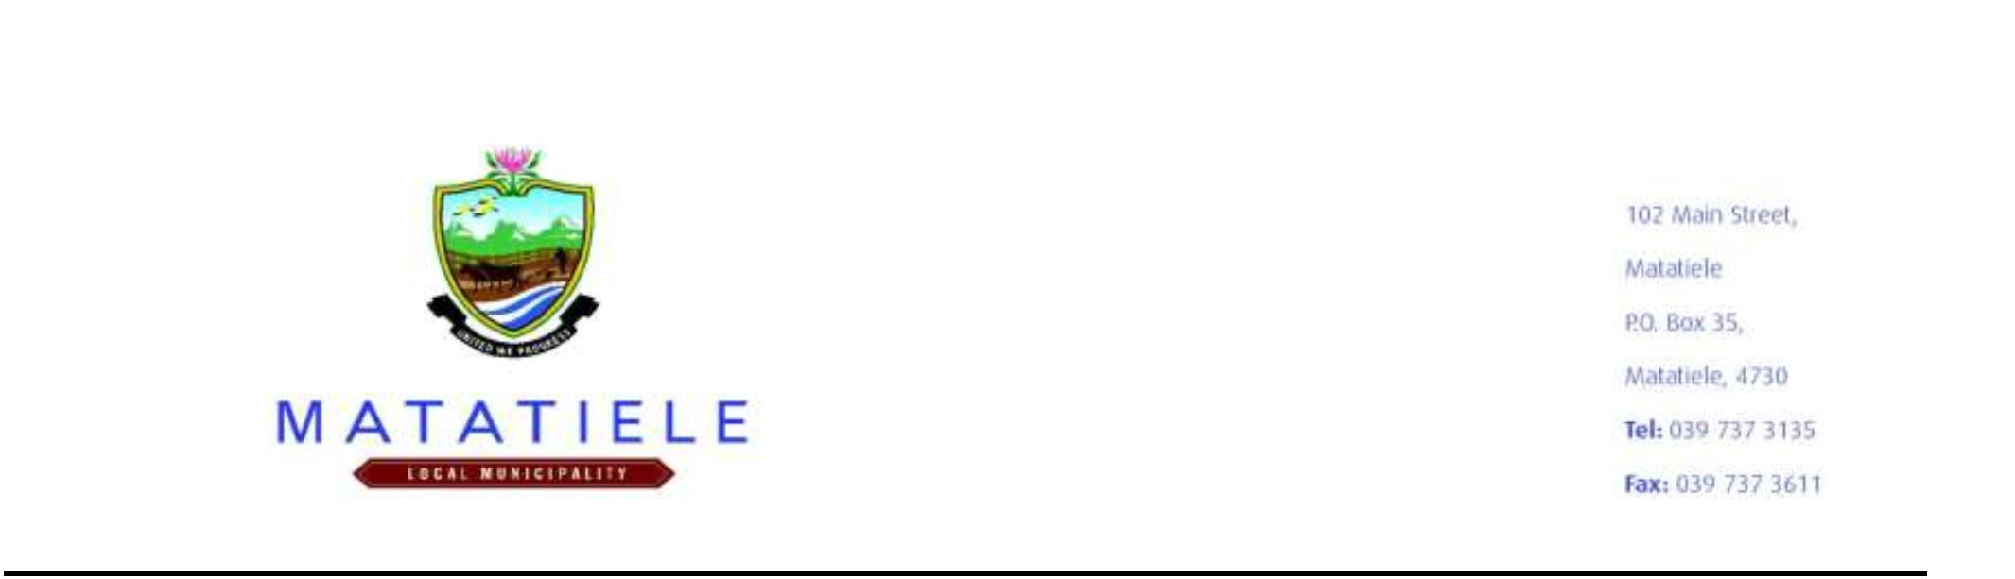

Following 2021 demarcation process, the Matatiele Local Municipality has increased its wards from twenty-six (26) wards to twenty-
seven (27) wards. It’s one of four municipalities with Alfred Nzo District Municipality, and it accounts for 25% of the District’s
Population. The municipality is about 4, 352 km2 areas size; the largest in the district. Municipal code: EC441
• Population size - 219 447 (Census 2016)
• Number of households - 56 872 (Census 2016)
• Youth population (15 -34) - 86 234 (Cs 2016)
Communication remains key to effective and efficient government even today (for implementation of policy, programmes, services and
projects.) Local government has been entrusted with the responsibility to deliver basic services and implementation of programmes
aimed at enhancing Local Economic Development in line with IDP priorities.
Communication is a key strategic service – to ensure that information is widely accessible within the public space, to engage citizens in
conversation around critical issues and to empower citizens to participate in not only shaping government policies but also in taking up
opportunities that affect their lives.
For the local sphere to fulfil this mandate effectively; consultative, democratic, integrated, participatory and developmental
communication become central to the developmental agenda of local government.
Effective communication can also contribute positively to government endeavours – leading to good governance, improved internal
staff and external citizen/stakeholder morale, and contributing towards meeting government’s aims and objectives. It further builds
public trust and confidence in the integrity of government and can be used to challenge any negative perceptions that might exist in the
public space.
CONTEXTUAL FRAMEWORK
➢ The Constitution of the Republic of South Africa, 1996 (Act 108 of 1996) provides the framework for communication within
the South African environment and regards freedom of expression and the public’s right to information as fundamental rights.
➢ Municipal Systems Act No 32 Of 2000, Municipal Structures Act 117 Of 1998.
➢ The Intergovernmental Relations Framework Act (IRFA), 2005(Act 13 of 2005)
➢ Matatiele LM Integrated and Development Plan (IDP).
➢ Government communication policy as approved by cabinet in 2018.
Draft MLM Communications Strategy 2021 – 2026
Page 2

Only two pages were converted.
Please Sign Up to convert the full document.
www.freepdfconvert.com/membership


