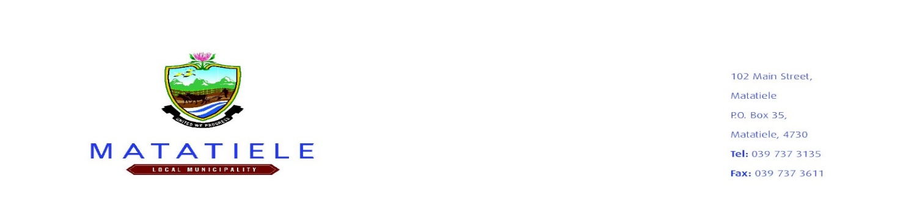

NOTICE NO:2021/2022-128
___________________________________________________________________________
NOTICE IN TERMS OF SECTION 116 (3) OF THE LOCAL GOVERNMENT: MUNICIPAL FINANCE MANAGEMENT ACT, 2003 (ACT 56 OF 2003) FOR THE AMENDMENT TO THE EXISTING CONTRACT FOR THE PROVISION OF FINANCIAL MANAGEMENT SYSTEM FOR A PERIOD OF THREE YEARS:

Notice is hereby given in terms of Section 116 (3) (a) and (b) of the Local Government: Municipal Finance Management Act, 2003 (Act 56 of 2003) that it is the intention of the Matatiele Local Municipality to amend the existing contract:
RT25-2016
DESCRIPTION: PROVISION OF FINANCIAL MANAGEMENT SYSTEM FOR A PERIOD OF FIVE (05) YEARS:
Service Providers: Munsoft (Pty) Ltd
Reasons for the proposed amendment: Due to the magnitude risk of losing financial data, systems compatibility and the limitation of technical capabilities to enable a seamless transition, we are unable to source the services of a financial system vendor. It is therefore impractical or cost ineffective for the municipality to appoint new service providers within a short space of time hence the process of extension is being implemented.
Notice is hereby given in terms of section 21 and 21Aof the Local Government: Municipal Systems Act, 2000 (Act 32 of 2000) that, the local community and interested/affected parties are invited to submit comments or representations to the municipality in respect of the above contract, such comments or representations must be received within 14 days of the advertisement via electronic mail or e-mail address provided below, or be hand delivered to the undersigned to mailing address provided hereunder. Persons who are physically disabled or who cannot read or write but wish to participate in the process, may come during office hours to the Mountain View Municipal Offices, Supply Chain Section, Budget and Treasury Office.
Comments and/or representations must be submitted to the following e-mail address zmatolo@matatiele.gov.za with subject line entitled 2021/2022-128’’COMMENTS ON NOTICE AMENDMENT TO THE CONTRACT OF PROVISION OF FINANCIAL MANAGEMENT SYSTEM FOR APERIOD OF THREE YEARS
The closing time for the submission of representations and/or comments must be received within 14 days of advertisement at 27/05/2022 at 12h00 pm
All enquiries regarding this intent can be directed to ZMatolo@matatiele.gov.za . Budget and Treasury Office, Mountain View Municipal Offices.

__________________________
MUNICIPAL MANAGER
MR. L MATIWANE

