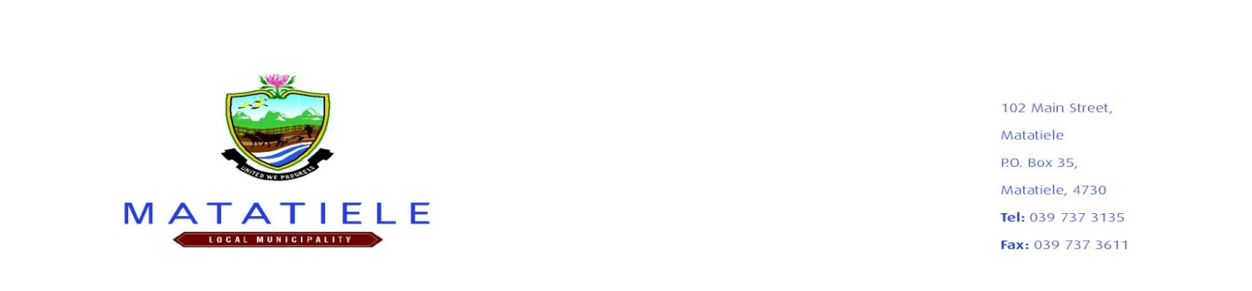
NOTICE OF PROPOSED POUND SALE
PUBLIC NOTICE: 2023/2024-54

Notice is hereby given in terms of the By-Law on Pound as adopted by the Council that the animals described hereunder are impounded in the Matatiele Pound and will be sold for cash without reserve to the highest bidder at the Matatiele Pound, by Public Auction on Tuesday, 29 August 2023 at 09h00, unless previously released.

Annexure listing of all items available for auction is collected free at Traffic office and also can be downloaded on website.

Interested bidders will have to apply for a Rates-Clearance Certificate at a cost of R94. 00 In order for them to participate in the bidding process. Proof of this must be presented before bidding so to be allowed onto the Pound site.
Any equerries should be directed to Mr. S Mbedla the General Manager: Community Services on telephone number 039 7378 115

__________________________________
MR. L. MATIWANE
MUNICIPAL MANAGER

