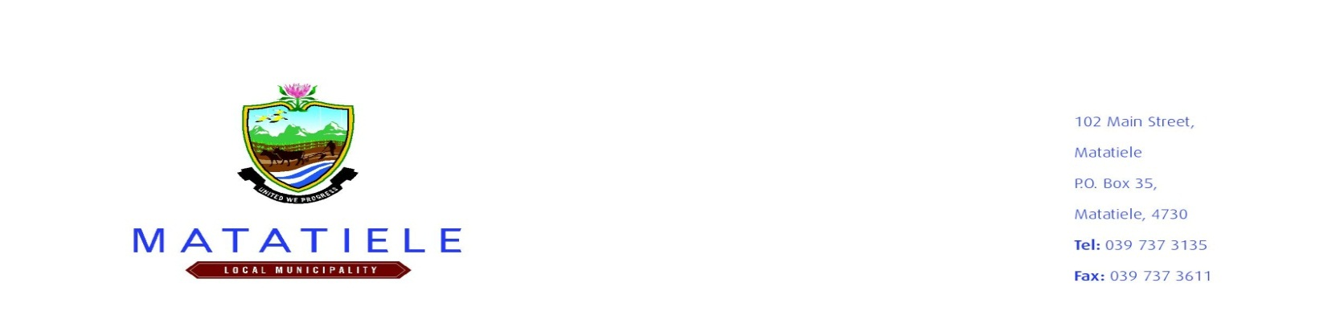

VACANCY ADVERT

DATE 20 MAY TO 27 MAY 2022

Matatiele Local Municipality is committed to the achievement and maintenance of diversity and equity in employment, especially in respect of gender, race and disability. Suitably qualified persons are hereby invited to apply for the following vacancies which will be filled in terms of the Employment Equity Plan of the Municipality. Candidates whose appointment will enhance representativity of employees from the designated groups are encouraged to apply.


PLEASE BEWARE OF THE SCAM WHERE INDIVIDUALS ARE REQUESTING MONEY IN EXCHANGE OF EMPLOYMENT WITHIN THE MUNICIPALITY AND PLEASE DO NOT MAKE ANY FORM OF PAYMENT IN RESPECT OF EMPLOYMENT OFFER.

DEPARTMENT : COMMUNITY SERVICES DEPARTMENT
Unit : Public Safety
Position: 8x Seasonal Fire Fighters
Employment Term | Six (6) Months Contract
Stipend | R3 487.68 per Month
Advertisement Platforms | Internal Municipal Notice Boards and Municipal website
Minimum Requirements | • Grade 10 • Certificate in Basic Fire Fighting • Six (6) months working experience in firefighting • Willingness to work over and above call of work and under pressure • Ability to pass the mandatory fitness test. NB: application must be accompanied by a proof of residence within the jurisdiction of Matatiele Local Municipality.
Key Responsibilities | • Receiving instructions/ guidance from the immediate superior on requirements and tools necessary for emergency firefighting • Attending emergency incidents including fires, road accidents, and spillages of dangerous substances, rail and air crashes. Cleaning up and checking the site after dealing with an incident. • Placing and stacking tools/ equipment in allocated positions according to size and type references • Ensuring that the store room is kept neat and tidy at all times. • Reporting to the supervisor about any tools/ equipment that needs to be replaced.
Closing Date : 27 May 2022 @ 16H00

Enquiries should be addressed to the Manager: Human Resources Management and Development, Mrs. E. Moeti either by email @ EMoeti@matatiele.gov.za or telephone (039) 737 8247

IMPORTANT NOTE TO APPLICANTS:
- Failure to submit documents listed below will result in disqualification of applicants;
- Background screening and vetting of qualifications and references will be conducted on shortlisted candidates;
- Proof of canvassing will lead to the disqualification of applicants;
- No faxed, emailed and late applications will be considered;
- Correspondence will be limited with selected applicants;
- The Municipality reserves the right not to appoint in respect of the advertised posts; and
- All appointments are made according to the Council conditions of service.

Please apply by filling in the Application for Employment Form obtainable from our website: www.matatiele.gov.za (not Z83 form) or from any of our Municipal Offices (Matatiele, Maluti, Cedarville and from a Ward Support Assistants in any of our 27 Wards). You must also send your Curriculum Vitae together with certified copies of your qualifications, identity document (ID) and valid code B driving licence (where applicable) to:

FOR ATTENTION: THE ACTING GENERAL MANAGER - CORPORATE SERVICES DEPARTMENT

The General Manager: Corporate Services The General Manager: Corporate Services
Matatiele Local Municipality OR Matatiele Local Municipality
P.O. Box 35 102 Main Street
Matatiele Matatiele
4730 4730

___________________________

MR. L. MATIWANE
MUNICIPAL MANAGER
Notice No : 2021/2022-192

The municipality urges all employees, members of council, clients, members of the public and our suppliers to report any kind of fraud or corruption at Matatiele Local Municipality`s Human Resources Management Unit.

