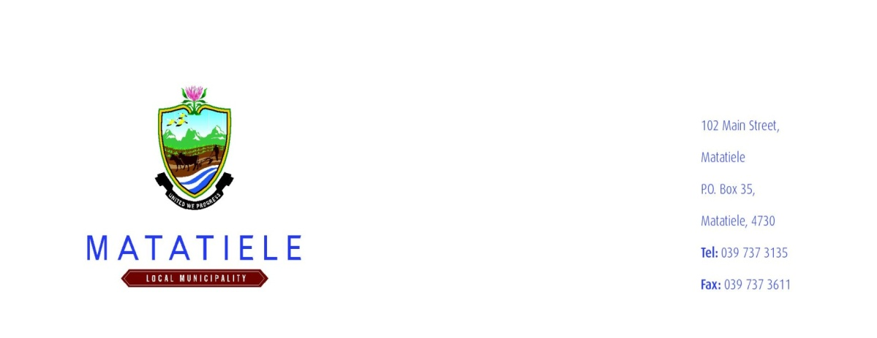

2025/2026 BUDGET COMMUNITY OUTREACH: 01 – 03 APRIL 2025
NOTICE NO: 2024/2025-118

PUBLIC NOTICE
Matatiele Local Municipality will conduct Community Budget Outreach in preparation for the financial year 2025/2026 Budget. This, is terms of sec23 (a) and (b) of Local Government: Municipal Finance Management Act (56 0f 2003). The Matatiele Local Municipality hereby invites the Community within the municipal area to attend 2025/2026 IDP/Budget Community Outreach Which will be held as follows:

ISAZISO
UMasipala weNgingqi yaseMatatiele uzakube etyelela uluntu eziwadini apho kuzabe kuboniswana khona ngenqubo phuhliso kunye nohlahlo lwabiwo mali, kanyaka-mali 2025/2026 ngoko Mthetho olawula ooMasipala ngokwesahluko 23 (a) no (b) we Local Goverment Finance Management Act (56 2003). Kungoko ke umasipala waseMatatiele emema uluntu olungqonge lo Masipala ukuza kwindibano ezakube ime ngoluhlobo:

TSEBISO
Masepala oa Lehae oa Matatiele o tla tshwara kopano le sechaba hobontshana katsa Moralo wantshetso pele hong lewa ditjelete tsa selemo sa ditjelete 2025/2026, hoya ka molao o laolang bo Masepala karolo ya 23 (a) leya (b) eleng Local Government: Municipal Finance Management act (56 waselemo 2003). Ka hona masepala oa lehae oa Matatiele o mema setjhaba kakakaretso hobateng pitsong tse tla tshwarwa. Lenaneo la dipitso le eme tjena.

OPENBARE KENNISGEWING
Matatiele Plaaslike Munisipaliteit sal gemeenskapsbegrotings uitreik ter voorbereiding van die begrotingsjaar 2025/2026. Dit is die bepalings van artikel 23 (a) en (b) van die Wet op Plaaslike Regering: Munisipale Finansiële Bestuur (56 0f 2003).Die Matatiele Plaaslike Munisipaliteit nooi hiermee die Gemeenskap binne die munisipale gebied uit om 2025/2026 GOP / Begrotingsgemeenskapuitreik by te woon, wat soos volg gehou word:

IDP COMMUNITY OUTREACH TIMETABLE

DATES | WARDS | VENUES | TEAMS | TIME
1 April 2025 | WARD 21 | Gwadane Community Hall | E | 10H00
1 April 2025 | WARD 10 | Magonqolweni Church | C | 10H00
1 April 2025 | WARD 03 | Masakala Hall | B | 10H00
1 April 2025 | WARD 02 | Mapateng Community Hall | C | 14H00
1 April 2025 | WARD 16 | Moeyaneng Community Hall | F | 10H00
1 April 2025 | WARD 04 | Bethel Community Hall | D | 10H00
1 April 2025 | WARD 13 | Mpharane Community Hall | A | 10H00
1 April 2025 | WARD 14 | Multi-Purpose Centre | G | 10H00
2 April 2025 | WARD 24 | Zibi mayor Community Hall | F | 10H00
2 April 2025 | WARD 15 | Qhobosheaneng Community Hall | B | 10H00
2 April 2025 | WARD 09 | Mphoshongweni Community Hall | A | 10H00
2 April 2025 | WARD 07 | Pamlaville Community Hall | E | 10H00
2 April 2025 | WARD 18 | Myemaneni Community Hall | C | 10H00
2 April 2025 | WARD 22 | Lukholweni Community Hall | D | 10H00
2 April 2025 | WARD 20 | Nokhwezi Community Hall | D | 18H00
2 April 2025 | WARD 25 | St Paul Community Hall | G | 10H00
3 April 2025 | WARD 08 | Nchodu Community Hall | A | 10H00
3 April 2025 | WARD 11 | Maloto Fora (Church) | F | 10H00
3 April 2025 | WARD 27 | Madimong Communuty Hall | C | 10H00
3 April 2025 | WARD 26 | Cedarville Town Hall | C | 15H00
3 April 2025 | WARD 01 | Maluti Civic Centre | A | 18H00
3 April 2025 | WARD 17 | Luxeni Community Hall | D | 10H00
3 April 2025 | WARD 06 | Red Cross | F | 14H00
3 April 2025 | WARD 23 | Matolong Almighty Gospel Church | E | 10H00
3 April 2025 | WARD 12 | Pontsheng Community Hall | B | 10H00
3 April 2025 | WARD 05 | Chibini- (Dalibunga Hall) | G | 10H00
3 April 2025 | WARD 19 | Matatiele Town Hall | D | 18H00

____________________
MR. L MATIWANE
MUNICIPAL MANAGER
NOTICE NUMBER: 2024/2025-118

